**House Keeping Services**

**Application**

**Abstract:**

The **Housekeeping Service App,** built with the **MERN stack**, provides a platform for booking various household services. Users register, log in, and access services like cleaning, pet care, and cooking. Upon login, they can view maid profiles, manage bookings, and access user profiles, ensuring organized service management.

The app utilizes **MongoDB** for data storage, Express for backend APIs, and React for a user-friendly interface. **JWT(JSON Web Token)** handles secure sessions, and secure payment gateways are integrated. Real-time updates keep users informed about bookings.

The backend manages user authentication and service provider data. This system enhances convenience by offering a centralized platform with detailed maid information. The optimized MERN architecture facilitates **scalability and reliability**, offering a seam less and efficient household service solution. It includes features like maid reviews and location -based recommendations.

**Introduction:**

The **Housekeeping Service App** is a web-based platform designed to streamline the booking and management of diverse household services. In today’s busy lifestyles, managing household chores can be overwhelming. This application offers a straightforward solution to schedule and oversee services like cleaning, pet care, and cooking efficiently.

Developed using the **MERN stack—MongoDB, Express.js, React, and Node.js**—the application ensures a smooth user experience with robust backend and frontend interactions. **MongoDB** stores user data, maid profiles, and booking details. **Express.js and Node.js** manage backend operations, including authentication, service management, and API handling. **React** provides a responsive and intuitive user interface for seamless service booking.

The Housekeeping Service App offers features like user authentication, maid profile browsing, service booking, and booking management. **JWT**-based authentication secures user access. The dashboard displays available services, maid profiles, and booking statuses, enabling effective service coordination.

Security is prioritized, with **secure payment gateways, session handling, and API protection.** Future enhancements may include service ratings, maid reviews, location-based service recommendations, and AI-driven scheduling optimization to enhance user experience.

In conclusion, the Housekeeping Service App is a **scalable and user-friendly** solution for managing household services. It improves convenience and efficiency by providing a structured platform to book and manage household tasks effectively.

**Design:**

The **Housekeeping Service App** adopts a **modular and scalable architecture**, ensuring a seamless user experience for booking and managing household services. It is built using the **MERN stack**, with each component playing a vital role in maintaining functionality and smooth interaction between the frontend and backend.

**Architecture Overview:**

**1) Frontend (React.js):** Provides an interactive and user-friendly interface for browsing

services, viewing maid profiles, and managing bookings. The UI is designed with

**HTML, CSS, and Bootstrap** to ensure responsiveness and ease of navigation.

**2)Backend (Node.js &amp; Express.js):** Manages user authentication, service catalog

management, booking scheduling, and communication between the database and the

frontend.

**3) Database (MongoDB):** Stores user credentials, maid profiles, booking details, and

service catalogs efficiently. Its **NoSQL** structure allows for scalability and flexibility in

handling diverse data structures.

**4) API Layer (RESTful APIs):** Connects the frontend and backend, enabling seamless data

exchange for service browsing, booking, and user management.

**User Interface Design:**

**1) User Authentication (Login &amp; Registration):**

* Clean and intuitive user interface for secure login and registration.
* Robust input validation to ensure accurate user data entry.
* JSON Web Token (JWT) based authentication for secure and persistent login sessions.

**2) Service Dashboard:**

* Provides a clear overview of pending, completed, and scheduled housekeeping tasks.
* Displays a list of available maids, including their names and prices, indicating their

availability for service.

* Displays a list of unavailable maids, including their names and prices.
* Offers convenient options to create, modify, remove, and mark tasks as finished.
* Easy-to-use navigation for seamless access to all app sections.

**3) Task/Service Management:**

* Enables users to input detailed maid requests, including descriptions of service needs, preferred service dates, and times.
* Allows users to easily update or cancel scheduled services as needed.
* Visually distinguishes completed tasks for clear progress tracking.
* Indicates if a maid is available or not for providing the service when the user is trying to book or change a service.

**4) Admin Panel (Optional):**

* Provides administrative tools to manage user accounts.
* Offers monitoring capabilities for system activity and client engagement.
* Allows the admin to manage service providers (maids), including their availability and pricing.

**Backend API Design:**

The system employs a RESTful API design to facilitate seamless communication between the frontend and backend.

**Authentication Routes:**

* POST /register – Registers a new client user for the housekeeping service.
* POST /login – Authenticates a client user and returns a JSON Web Token (JWT) for secure session management.

**Housekeeping Service Management Routes:**

* GET /services – Retrieves the list of housekeeping service bookings for a client user.
* POST /services – Creates a new housekeeping service booking.
* PUT /services/:id – Updates the details of a housekeeping service booking.
* DELETE /services/:id – Cancels a housekeeping service booking.

**Security Design:**

Security is paramount in the Housekeeping Service App, ensuring the protection of client and service provider data.

* **Token-based Authentication:** JSON Web Tokens (JWT) are used to manage client and service provider sessions and secure API access.
* **Data Encryption:** Client and service provider passwords are hashed using robust algorithms before being stored in the database.
* **Input Validation &amp; Error Handling**: Comprehensive input validation and error handling mechanisms are implemented to prevent common security vulnerabilities, such as SQL injection and cross-site scripting (XSS) attacks.

**UI/UX Considerations:**

* **Responsive Design:** The app is designed to work seamlessly across desktops, tablets, and mobile devices.
* **User-Friendly Navigation:** Simple layout with clearly labeled buttons and forms for intuitive usage.

**Future Enhancements:**

* **Service Prioritization and Categorization:** Clients will be able to assign priority levels (e.g., Urgent, Standard, Flexible) and categorize service requests (e.g., Deep Cleaning, Regular Cleaning, Special Request) for better service coordination.
* **Reminders and Notifications:** Integration of reminders via email or push notifications to notify clients about upcoming appointments and service providers about scheduled jobs.
* **Provider-Client Communication:** Implement in-app messaging or chat features to allow direct communication between clients and service providers for clarifications or special requests.
* **AI-Powered Service Recommendations:** Machine learning-based recommendations for service scheduling, provider selection, and customized cleaning plans based on client preferences and historical data.
* **Mobile App Integration:** Native Android/iOS application for seamless cross-device service booking and management.
* **Service Provider Rating and Review:** Implement a rating and review system to allow clients to provide feedback on service quality, improving accountability and service standards.
* **Payment Integration:** Implement secure in-app payment processing for convenient and seamless transactions.

The **Housekeeping Service App** is designed to be **scalable and future-proof,** allowing for additional features to enhance client satisfaction and service efficiency.

**Modules:**

The **Housekeeping Service App** is structured into distinct modules to ensure robust functionality, streamlined maintenance, and future scalability. Each module is designed to handle specific functionalities, contributing to the overall efficiency and organization of the system.

**Authentication Module:**

**Purpose:**

Manages client and service provider registration and login.

**Features:**

* Client and service provider registration with robust input validation and error handling.
* Secure login using JSON Web Token (JWT) authentication for both clients and service

providers.

**API Endpoints (Client Profile Management):**

* GET /api/profile – Retrieves the clients profile data.
* POST /api/update-profile – Updates the clients profile details.

**Service Management Module (Housekeeping Service App):**

**Purpose:**

Enables clients to create, edit, update, delete, and manage housekeeping service bookings.

**Features:**

* Clients can create new service bookings with service descriptions, preferred dates and times, and maid selections.
* Service bookings can be edited, cancelled, or marked as completed.
* Real-time updates on service booking status changes.

**API Endpoints (Service Management):**

* GET /api/services – Retrieves a list of the client’s service bookings.
* POST /api/services – Creates a new service booking.
* PUT /api/services/:id – Updates an existing service booking.
* DELETE /api/services/:id – Cancels a service booking.

**Dashboard Module:**

**Purpose:**

Provides an interactive interface for managing housekeeping service bookings and

viewing service provider availability.

**Features:**

* Displays pending, completed, and scheduled housekeeping service bookings.
* Displays available and unavailable service providers (maids) and their prices.
* Quick access to service booking creation, editing, and cancellation options.

**API Usage:**

* The dashboard dynamically fetches data from the /api/services and /api/providers APIs.

**Reminder and Notification Module (Future Enhancement):**

**Purpose:**

Notifies clients about upcoming service appointments and service providers about

scheduled jobs.

**Features:**

* **Email or SMS alerts** for service appointment confirmations and reminders.
* **Push notifications** for appointment updates, cancellations, or urgent messages.
* **Recurring reminders** for scheduled regular cleaning services.

**Collaboration Module (Future Enhancement):**

* **Purpose:** To create a more interactive, transparent, and efficient service experience for both customers and housekeepers.
* **Key Features:**
  + **Book & Assign:** Streamlining the customer's selection of services and maids, and automating scheduling.
  + **Live Updates:** Providing real-time job status updates for both managers and customers, improving transparency.
  + **Job Chat:** Facilitating direct communication between customers and maids within each job for clarity and problem-solving.
  + **Location (Optional):** Offering real-time GPS tracking of maids during service for enhanced customer and manager oversight.
  + **Checklists:** Implementing digital checklists to ensure consistent and thorough task completion.

**Admin Panel Module (Optional/Future Enhancement):**

* **Purpose:** To empower managers with the tools and data needed to effectively oversee operations, improve efficiency, and enhance customer satisfaction.
* **Key Features:**
  + **Users & Bookings:** Centralized management of customer and maid accounts, as well as service bookings.
  + **Performance:** Tracking maid performance, gathering customer feedback, and monitoring real-time locations to optimize service quality.
  + **Reports:** Generating insightful reports on service trends, booking patterns, and maid efficiency to inform strategic decisions.
  + **Areas:** Efficiently managing service areas and assigning maids to specific locations.
  + **Supplies:** Tracking supply usage and automating reordering to ensure smooth operations.

**API Endpoints**

* **GET /api/admin/users** – Get a list of all users (customers and cleaners).
* **GET /api/admin/tasks** – Get all service tasks (cleaning jobs) for admin review.

### **Module Interaction Flow:**

1. **User Login/Register:**
   * Users sign up or log in 🡪 A token is created to keep them logged in securely.
2. **Service Booking & Management:**
   * Users can book housekeeping services from the dashboard 🡪They can also update, cancel, or check the status of bookings.
   * Status updates happen in real-time (e.g., booked, in-progress, done).
3. **Reminders & Alerts:**
   * The app sends reminders before a booking.
   * Users get alerts for cleaner arrival or changes in schedule.
4. **Team Collaboration:**
   * Shared accounts for households or teams.
   * Everyone can view and update service info together.
5. **Admin Features:**
   * Admin can see all users and bookings.
   * Tracks activity, cleaner performance, and system usage.
6. **Payments :**
   * Users can pay for premium services (e.g., regular weekly cleaning).
   * Payments are processed safely.
   * Premium users get extra features and benefits.

**Architecture:**

The **House Keeping Service App** follows a **three-tier architecture** to ensure modularity, scalability, and effective management of housekeeping tasks and bookings.

**1. Presentation Layer (Frontend)**

The **Presentation Layer** provides an intuitive and responsive user interface that allows users to interact with the system seamlessly.

**Technologies Used:**

* **HTML5, CSS3, JavaScript** for core structure and styling.
* **React.js** for building dynamic and reusable components.
* **Bootstrap / Tailwind CSS** for responsive layouts.
* **Axios / Fetch API** for handling API calls.

**Key UI Components:**

* **User Authentication Pages:** Login and Register
* **Service Dashboard:** Displays available services, bookings, and staff assignments.
* **Booking Interface:** Users can book services (e.g., cleaning, laundry, maintenance).
* **Admin Panel:** View/manage services, users, and staff assignments.

**Communication Flow:**

* Fetches services and booking data via APIs (e.g.,/api/services, /api/bookings)
* Sends user inputs to the backend to create/update bookings or profiles

**2. Application Layer (Backend)**

This layer connects the frontend and the database while handling logic and data flow.

**Technologies Used:**

* **Node.js + Express.js** for creating RESTful API routes
* **JWT (JSON Web Token)** for secure session handling
* **Middleware** for validation, error handling, and logging

**Key API Endpoints:**

**Authentication APIs:**

* POST /api/register – Registers a new user
* POST /api/login – Authenticates and returns JWT

**Housekeeping Services APIs:**

* GET /api/services – Fetch all available services
* POST /api/services – Admin: Add new service
* PUT /api/services/:id – Admin: Update service
* DELETE /api/services/:id – Admin: Remove service
* **Booking APIs:**
* GET /api/bookings – Fetch all bookings for a user
* POST /api/bookings – Create a new service booking
* PUT /api/bookings/:id – Modify booking
* DELETE /api/bookings/:id – Cancel booking

**User Profile APIs:**

* GET /api/profile – Retrieve user profile
* POST /api/update-profile – Update user details

**Business Logic:**

* Validates requests (e.g., is booking valid, service available?)
* Manages booking lifecycle and service status
* Ensures secure user access through JWT
* Links users to specific bookings an

**3. Data Layer (Database)**

Handles persistent data storage with secure and scalable schema design.

**Database: MongoDB** (with Mongoose ORM)

**Collections:**

**Users Collection:**

* Fields: username, email, password, role (user/admin)
* Uses bcrypt for secure password hashing

**Services Collection:**

* Fields: serviceName, description, price, category, availability

**Bookings Collection:**

* Fields: userId, serviceId, bookingDate, status, address, notes

**Staff Collection** :

* Fields: name, assignedServiceId, availability, contactInfo

**Data Flow in the System:**

**1. User Authentication:**

* **Flow:**
  + User submits credentials → Request sent to /api/login
  + Backend validates user credentials
  + If valid, **JWT token is generated** and returned
  + **Frontend stores the token in local Storage** or cookies

**2. Service Booking Management:**

* **Flow:**
  + User selects a service and fills booking form → Request sent to /api/bookings
  + Backend validates booking details → MongoDB updated with new booking
  + Response returned to frontend with booking confirmation

**3. Session Management:**

* **Flow:**
  + Every protected API request includes JWT in the Authorization header
  + Backend validates token:
    - If **valid**, request proceeds
    - If **expired/invalid**, user is redirected to login

**High-Level Architecture Diagram**

┌───────────────────────────────┐

│ Presentation Layer │

│ (React, HTML, CSS, JS)│

└─────────────┬─────────────────┘

│

▼

┌───────────────────────────────┐

│ Application Layer │

│ (Node.js + Express.js) │

└─────────────┬─────────────────┘

│

▼

┌───────────────────────────────┐

│ Data Layer │

│ (MongoDB + Mongoose) │

└───────────────────────────────┘

**Security & Session Management:**

* **JWT Authentication:** Secure access to protected resources and Stored securely on client side (via localStorage or cookies)
* **Input Validation & Sanitization:** Protects against XSS and NoSQL injection attacks
* **Token Expiry Management:** Automatic logout or re-authentication prompt on expiration.

**Scalability & Future Enhancements**

* **Microservices Architecture:** Modularize services (authentication, bookings, payments, etc.) Can be implemented for better scalability.
* **Cloud Deployment:** Host backend APIs and the database on cloud platforms.
* **Reminders & Notifications:** Integrate email/SMS reminders
* **Staff Collaboration Features:** Assign bookings to staff, enable task status tracking
* **Calendar Integration:** Show upcoming bookings on user’s dashboard

This modular and well-structured architecture ensures that the House Keeping Service Application is scalable, secure, and easily extendable for future improvements.

**Coding:**  
**Frontend:**

**bc.html(home page)**

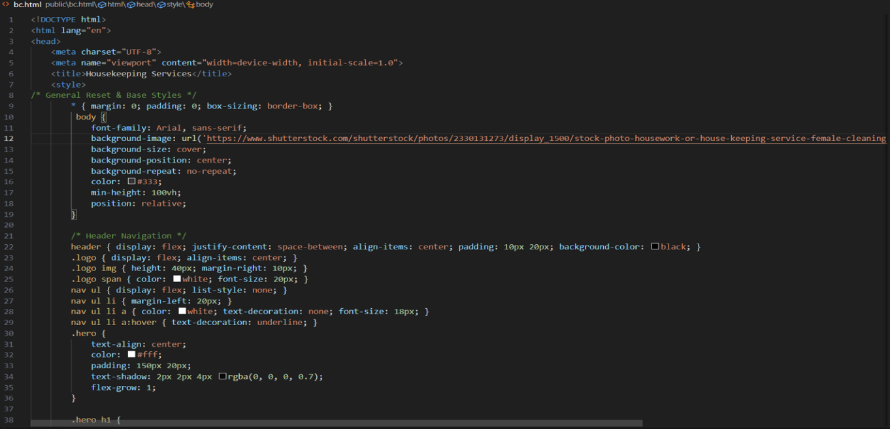

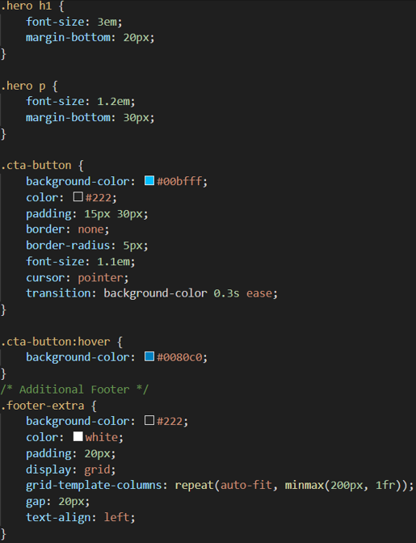

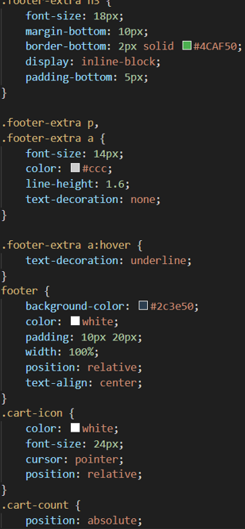

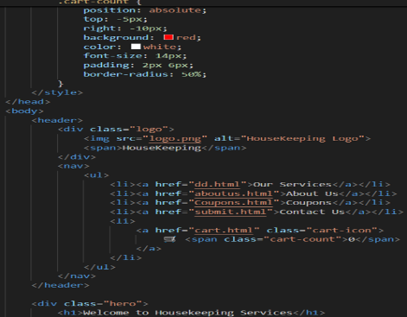

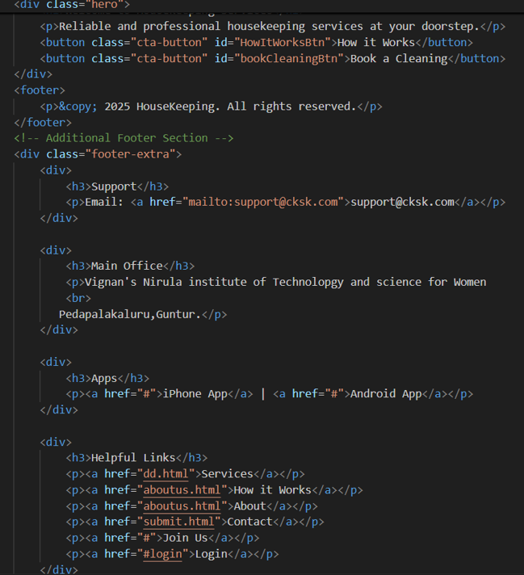

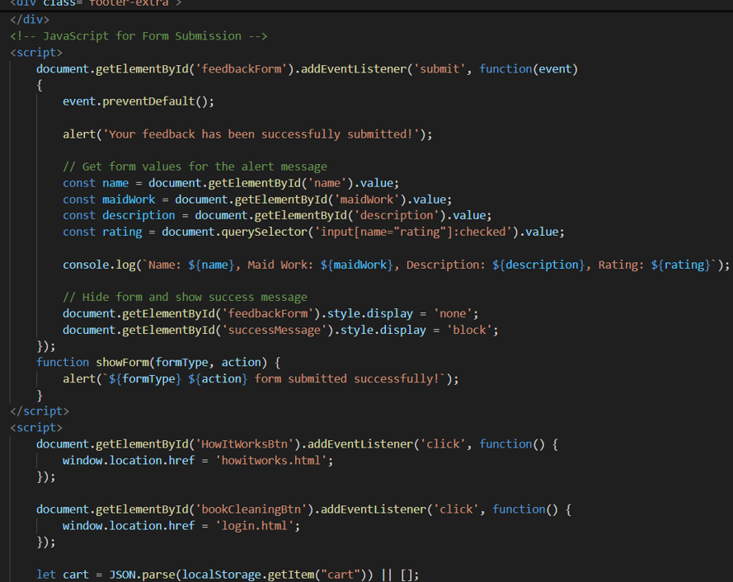

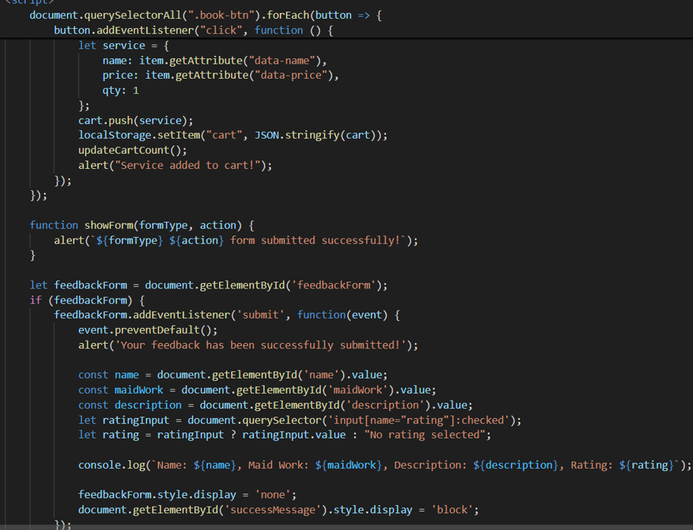

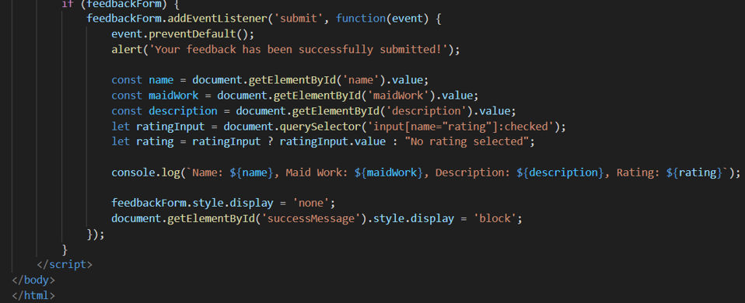

**Login&register.html**

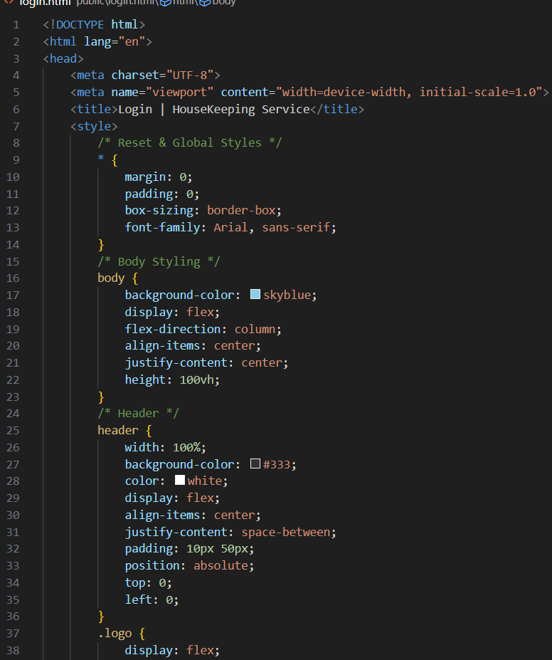**Login.html**

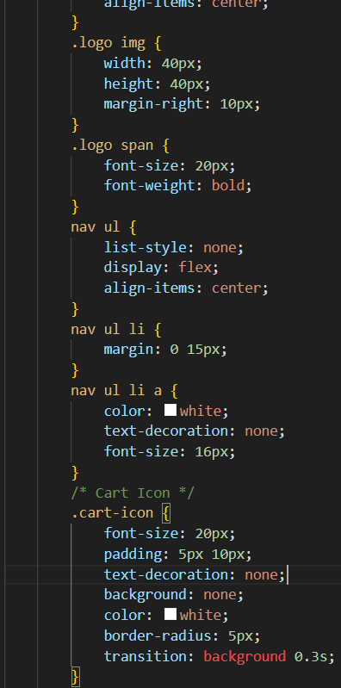

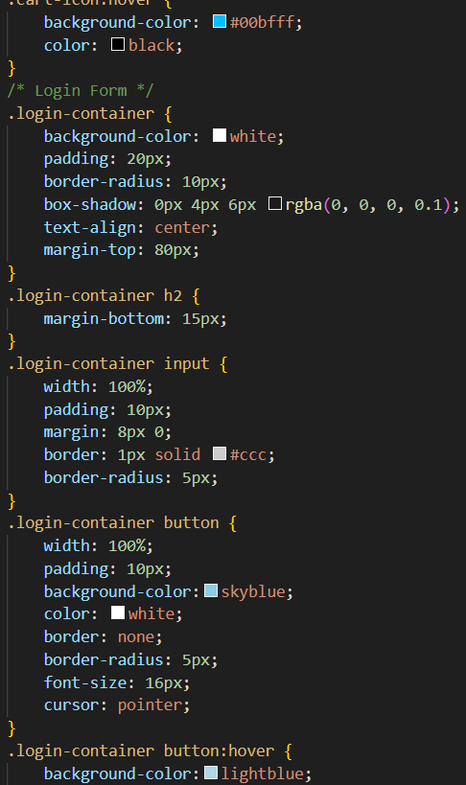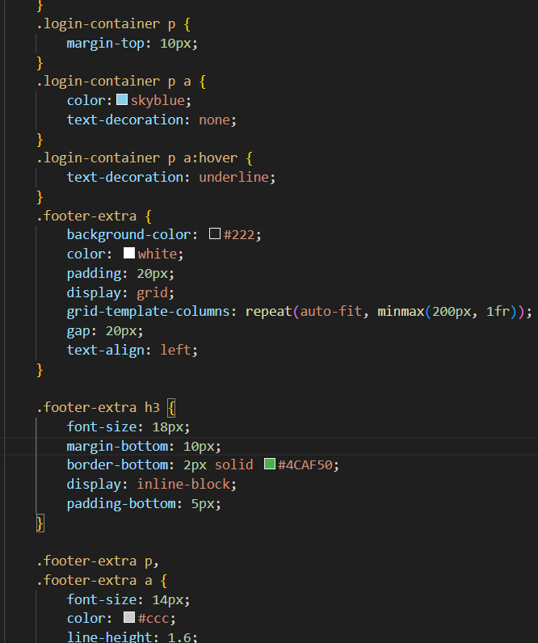

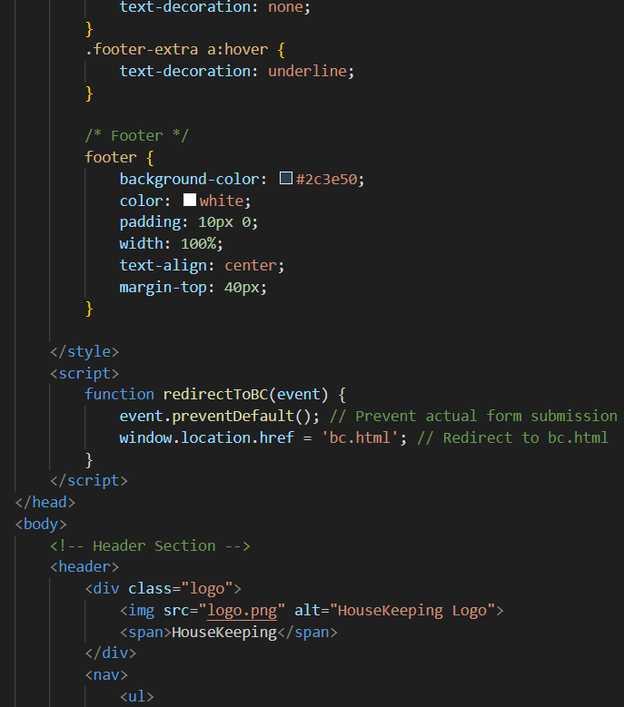

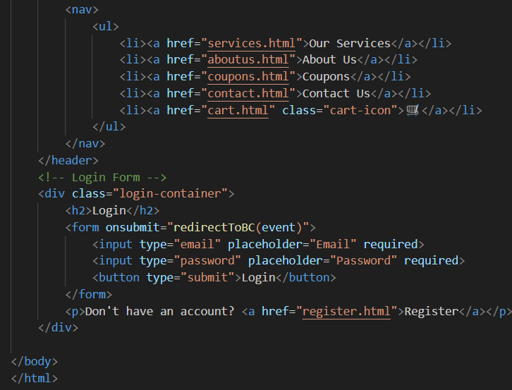

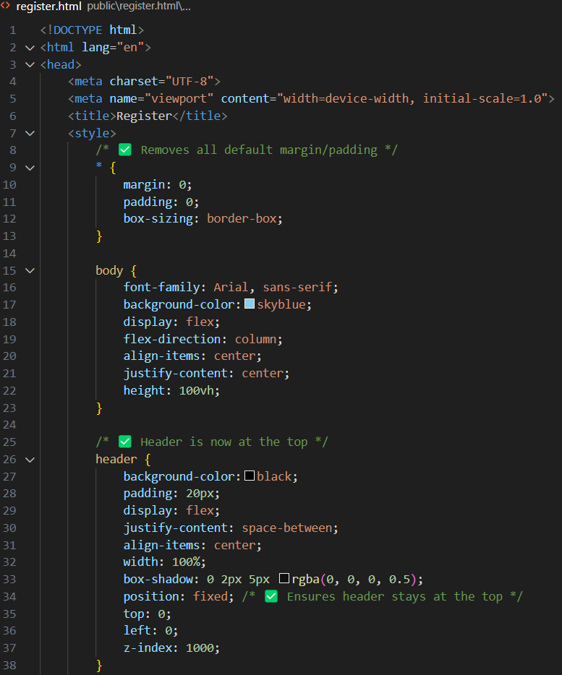**Register.html**

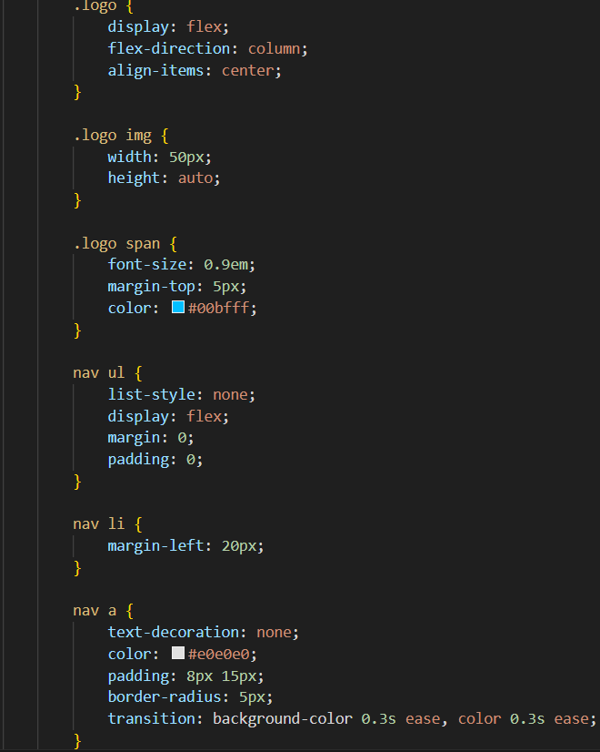

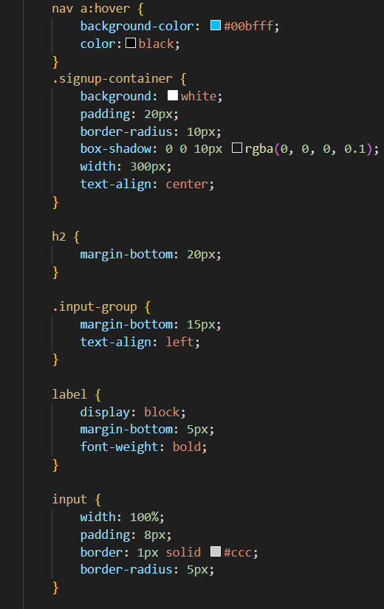 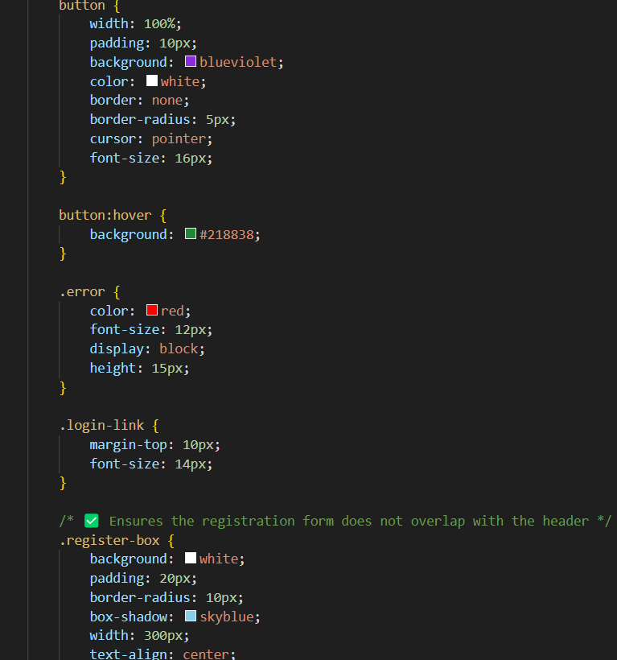

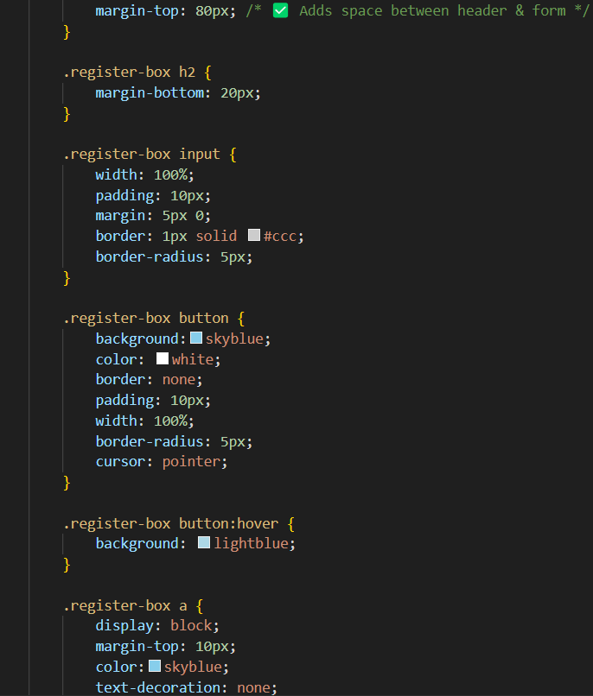

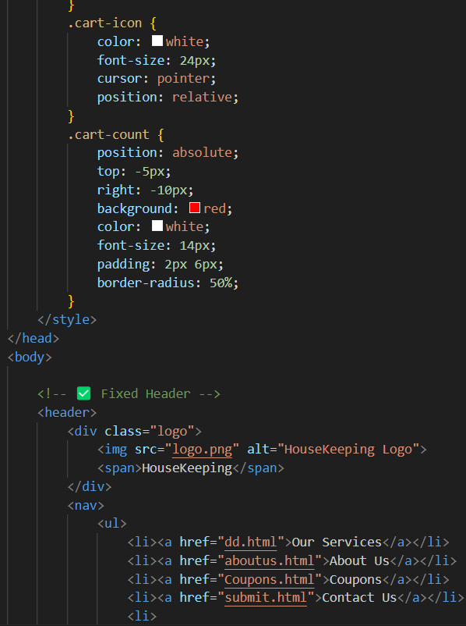

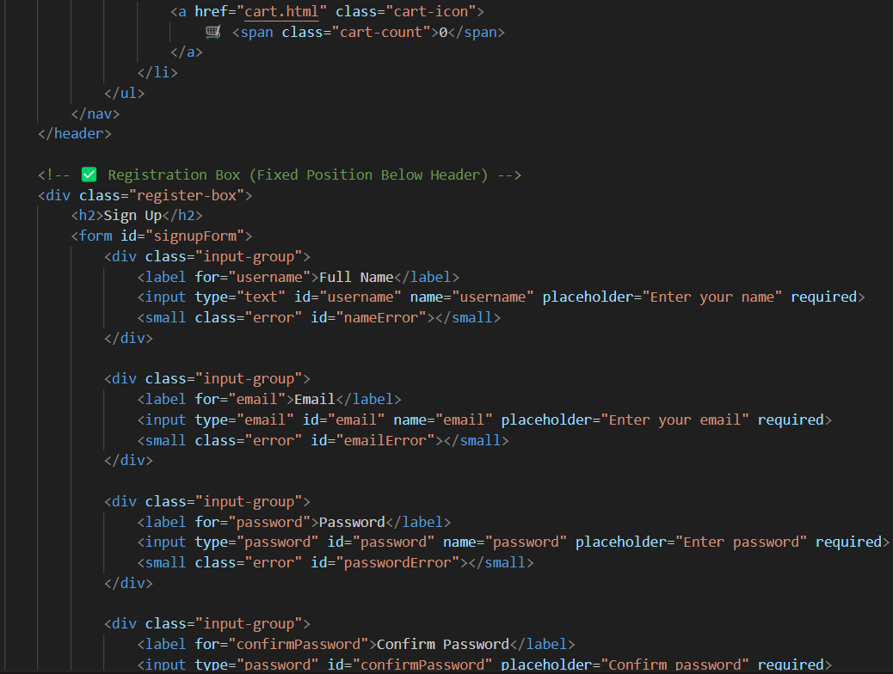

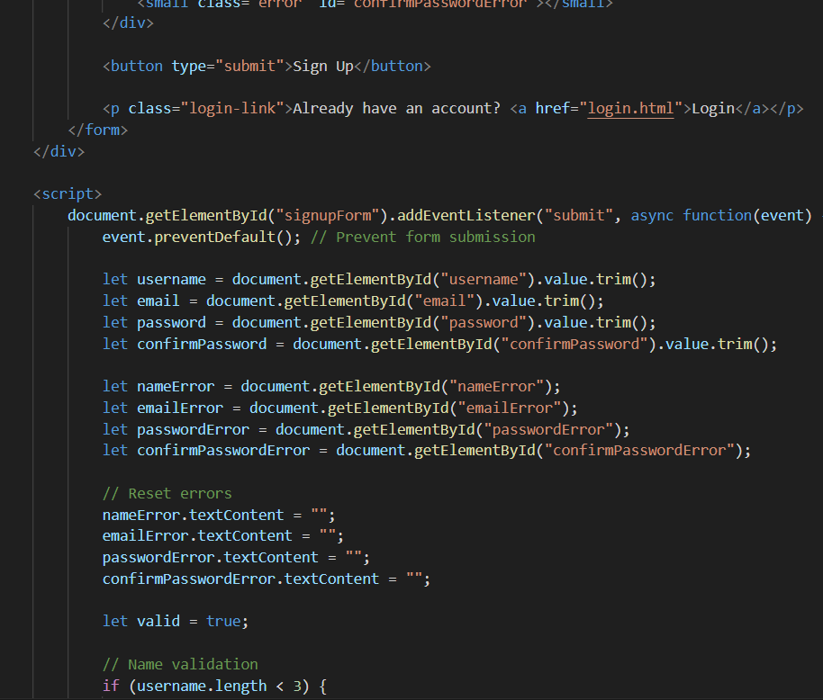

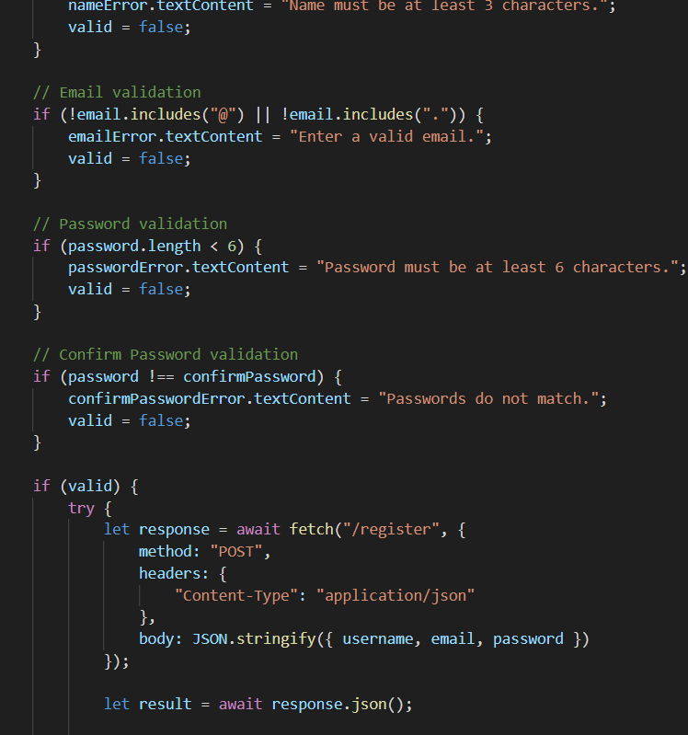

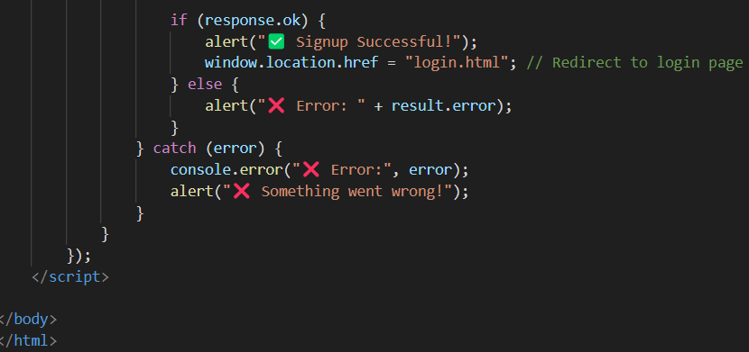

**Howitworks.html**

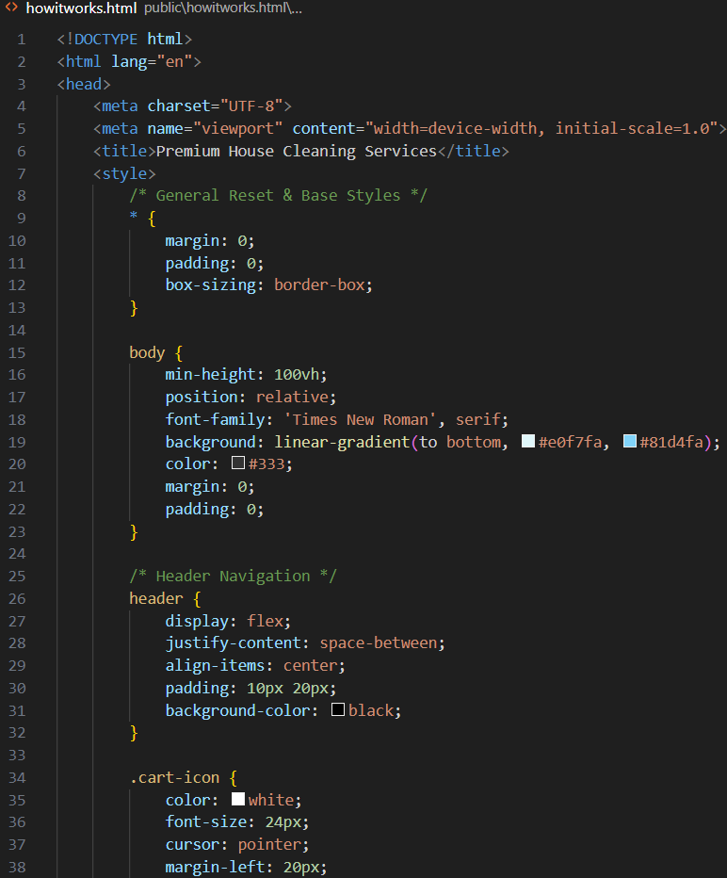 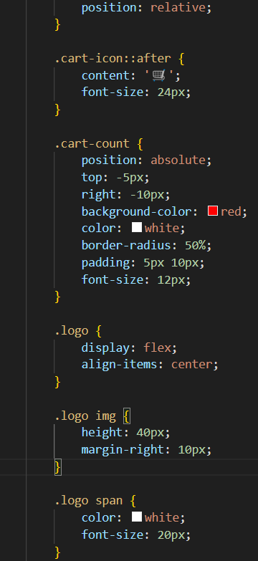

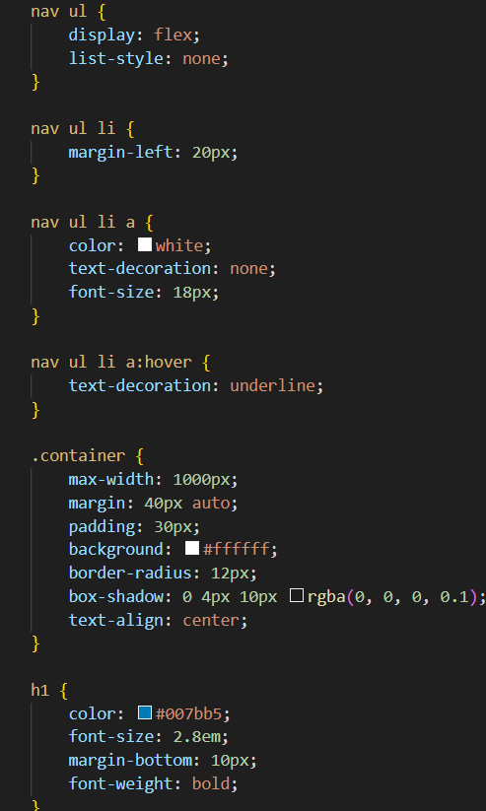 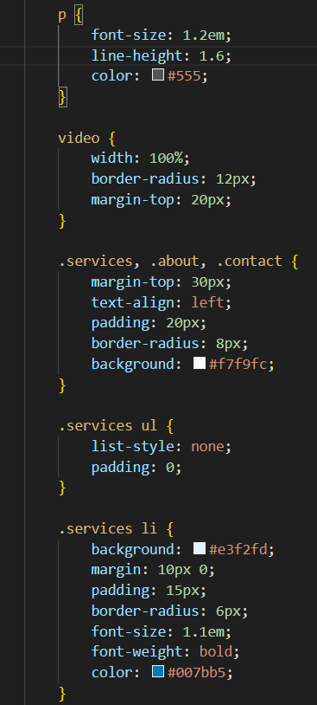

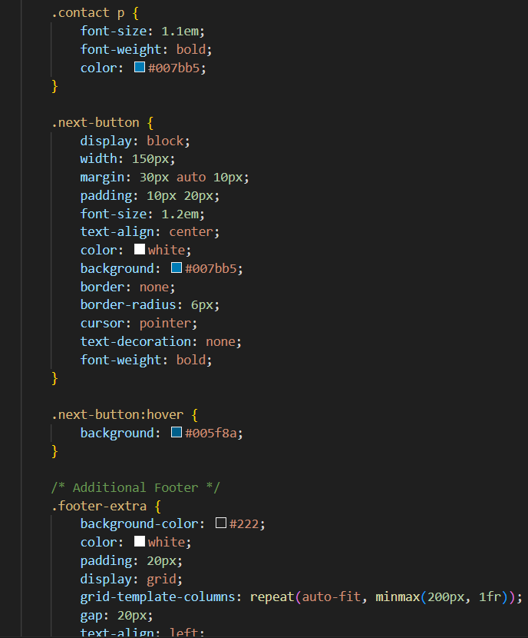 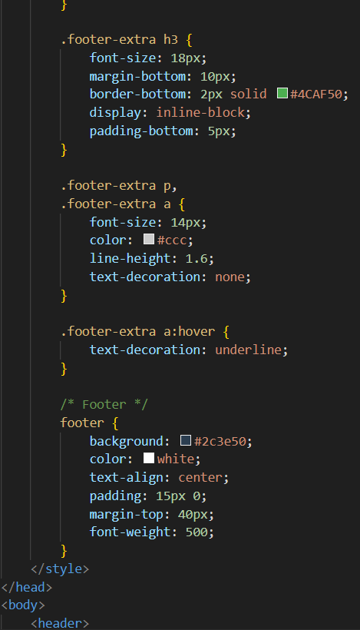

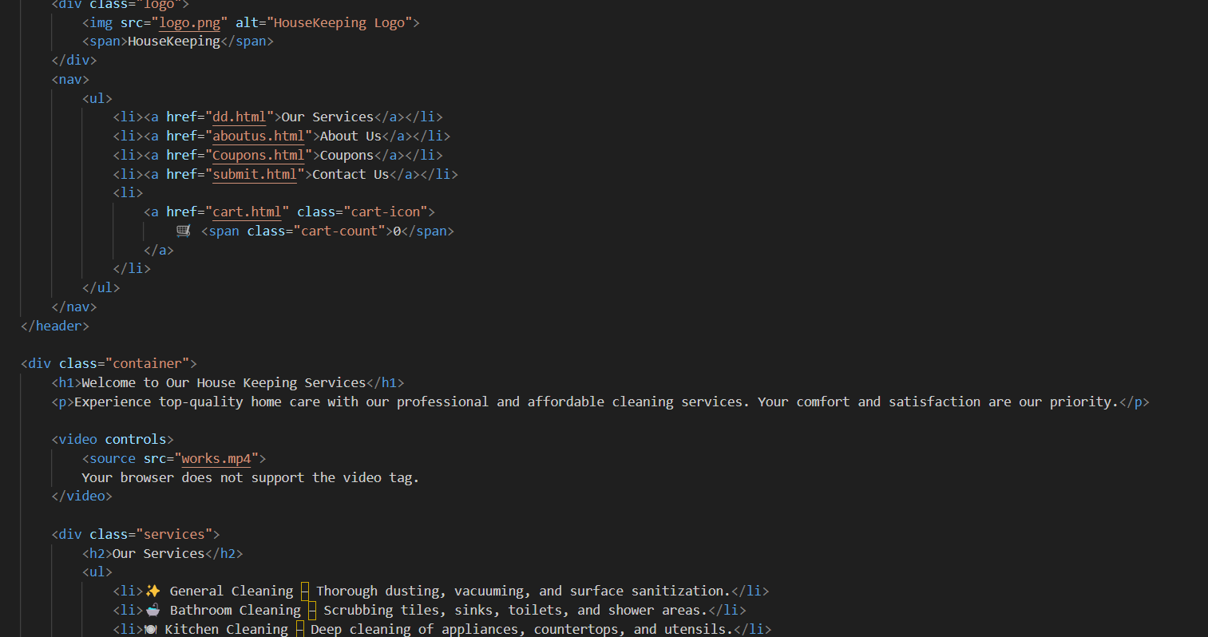

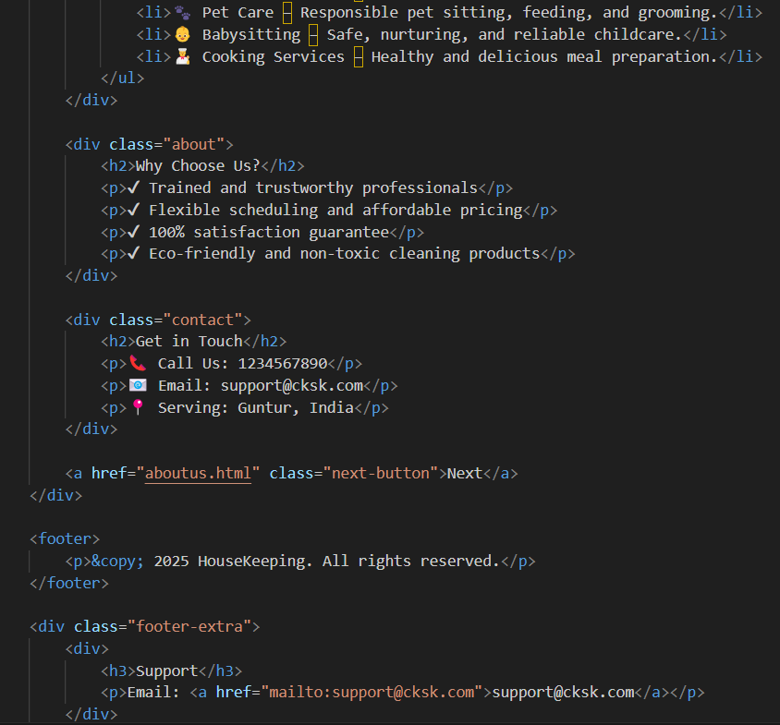

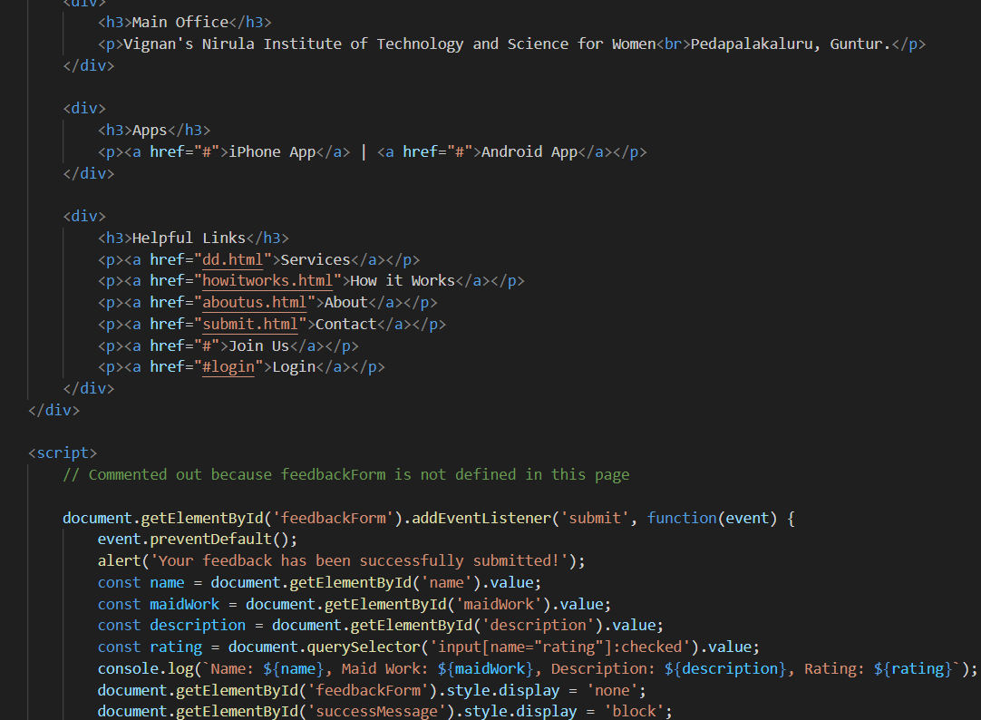

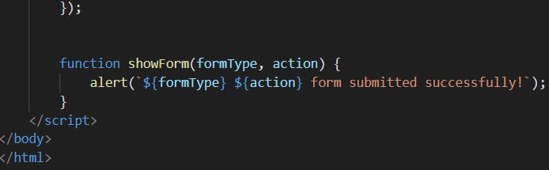

**aboutus.html**

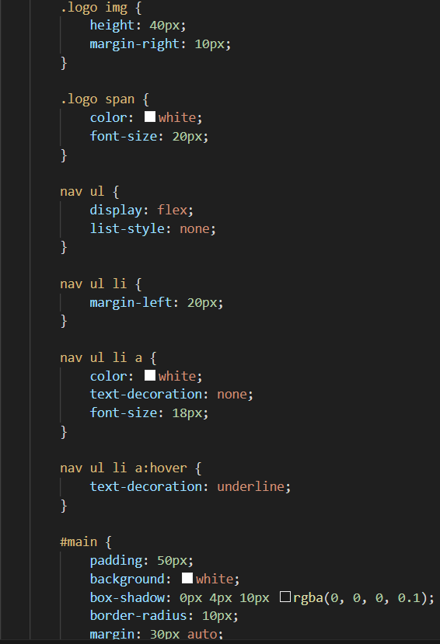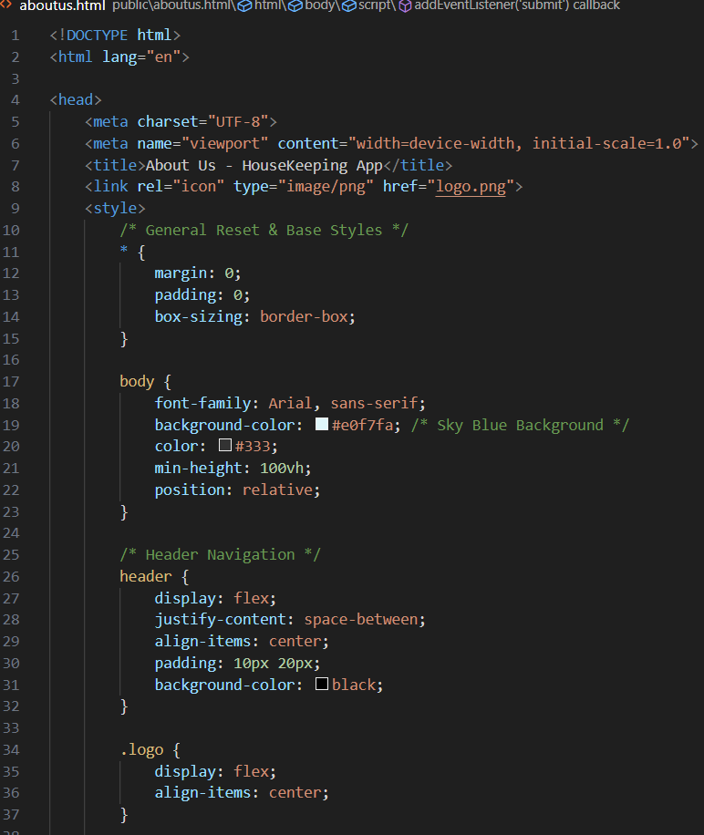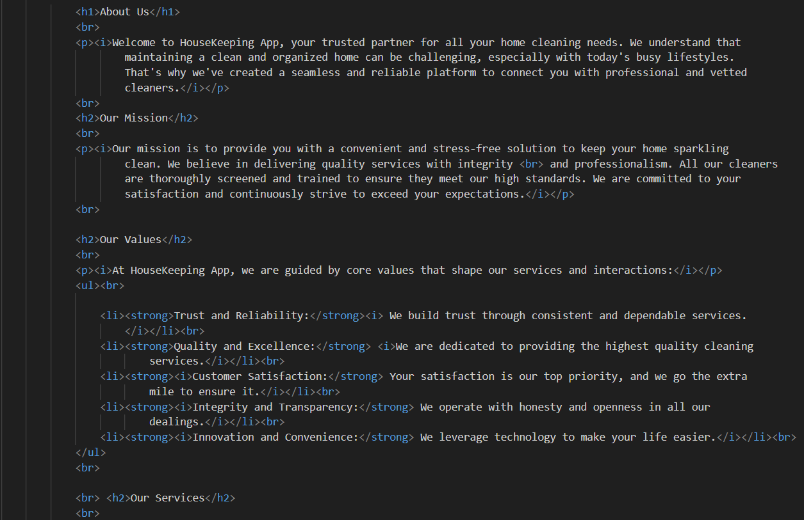

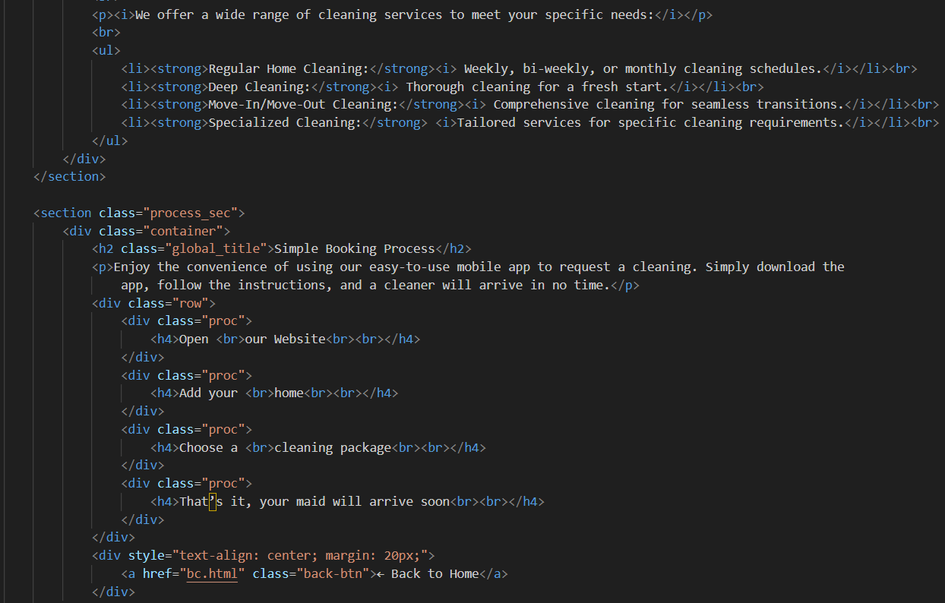

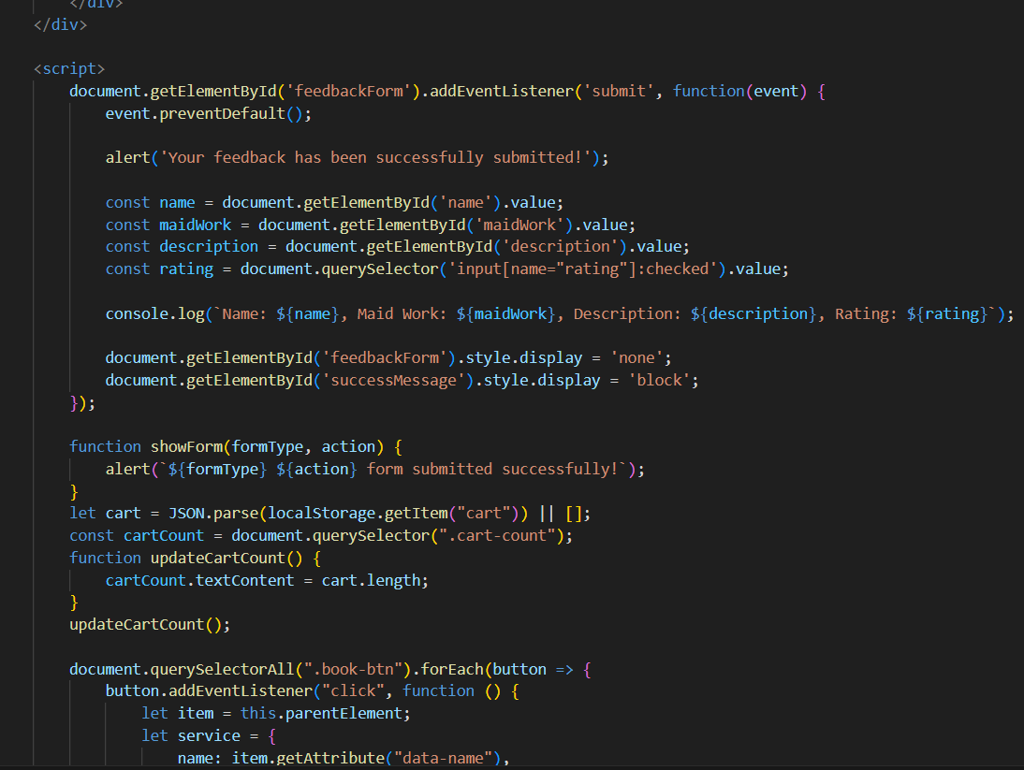

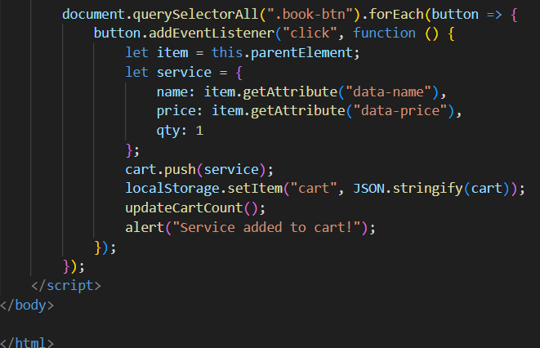

**Our services(dd.html)**

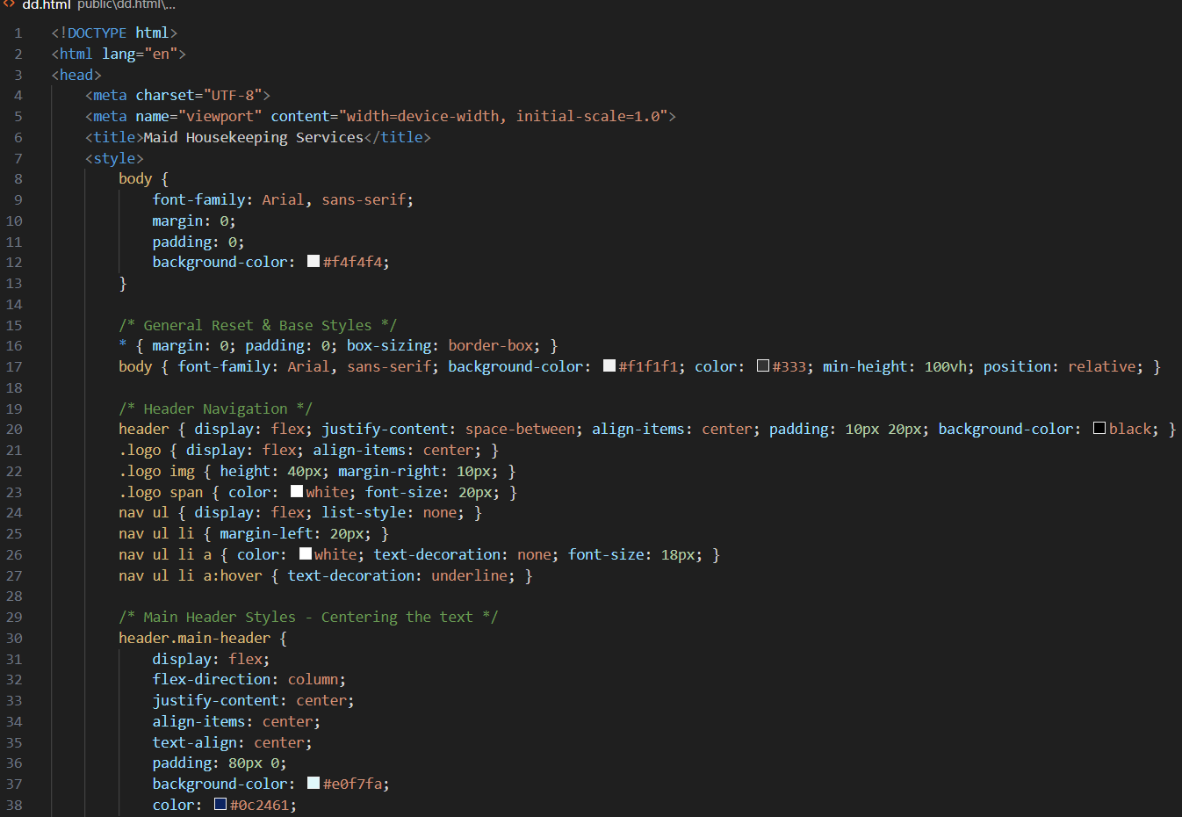

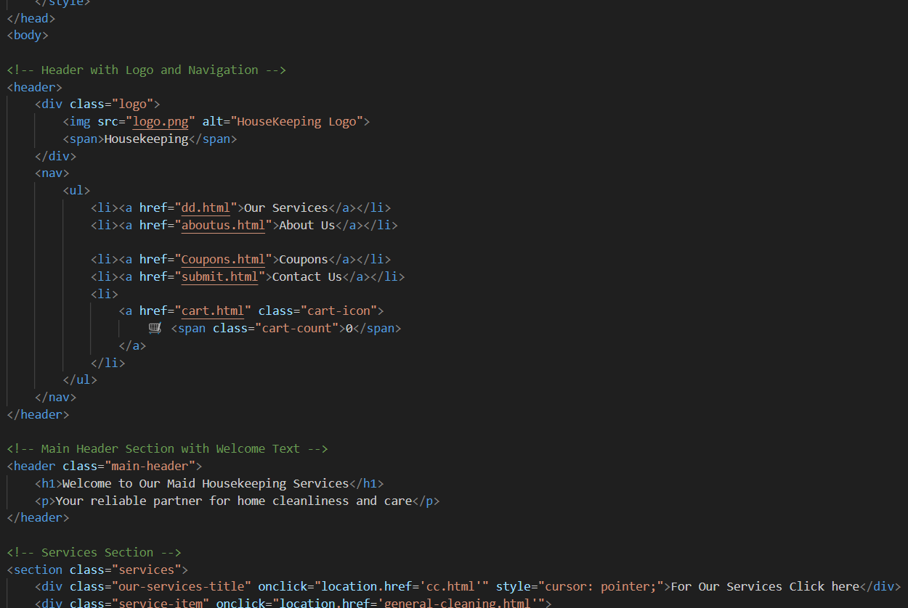

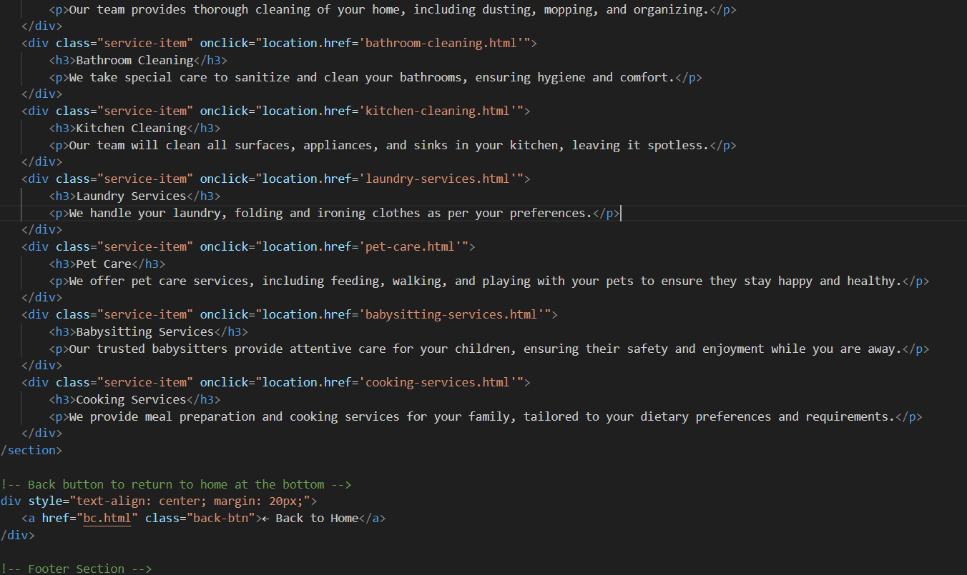

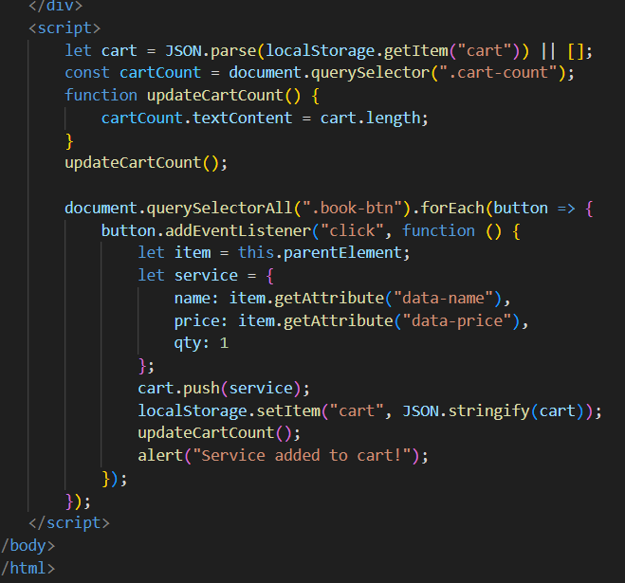

**cc.html (services providing in housekeeping application)**

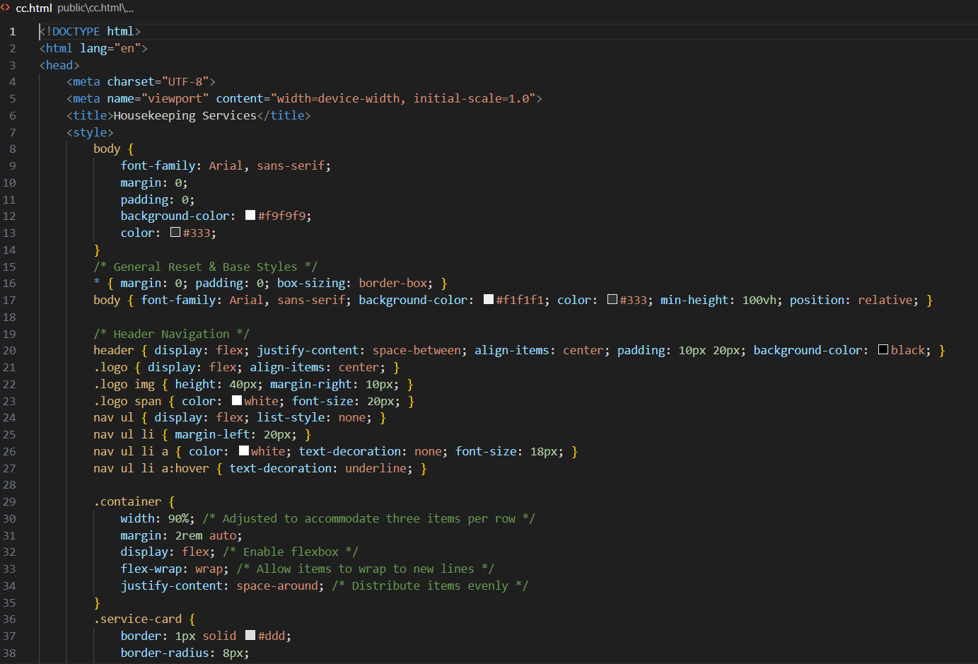

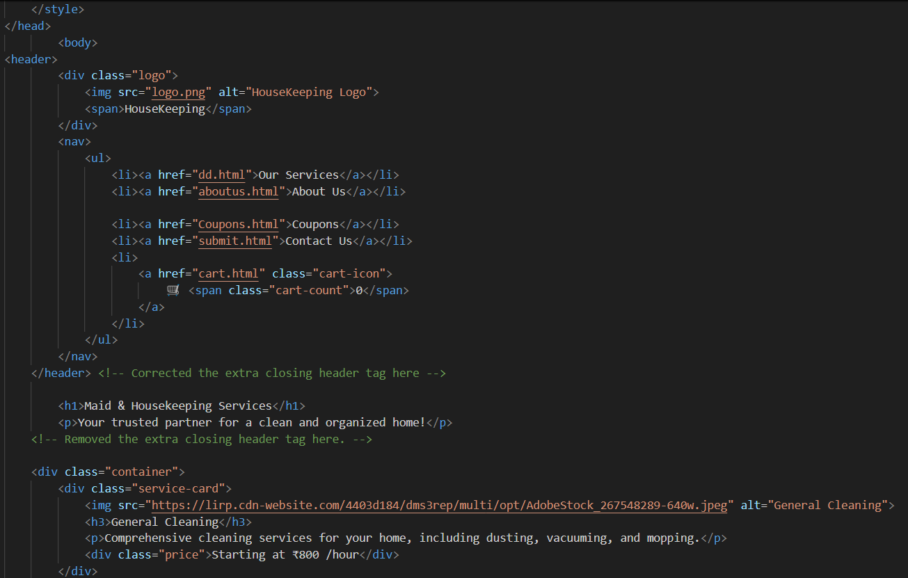

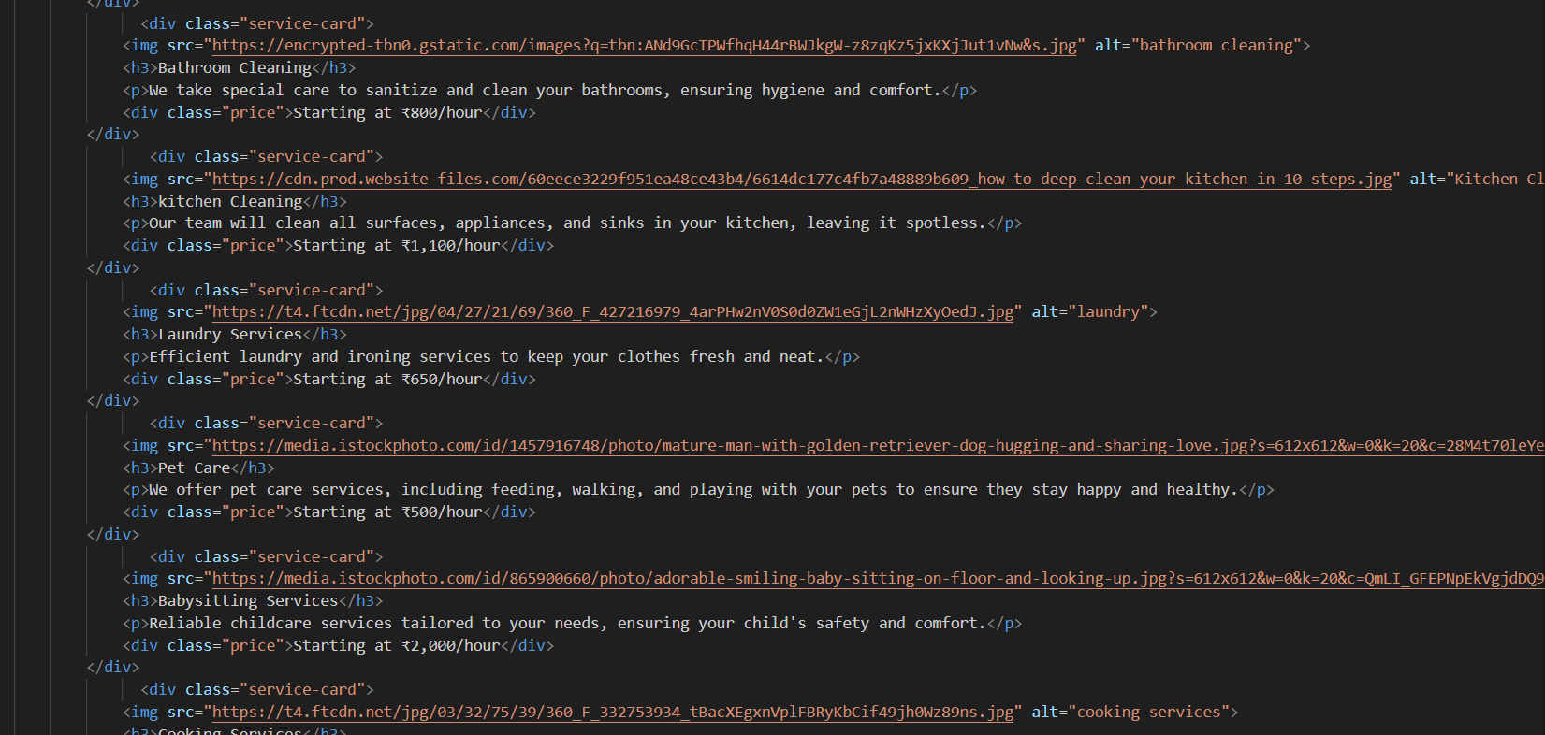

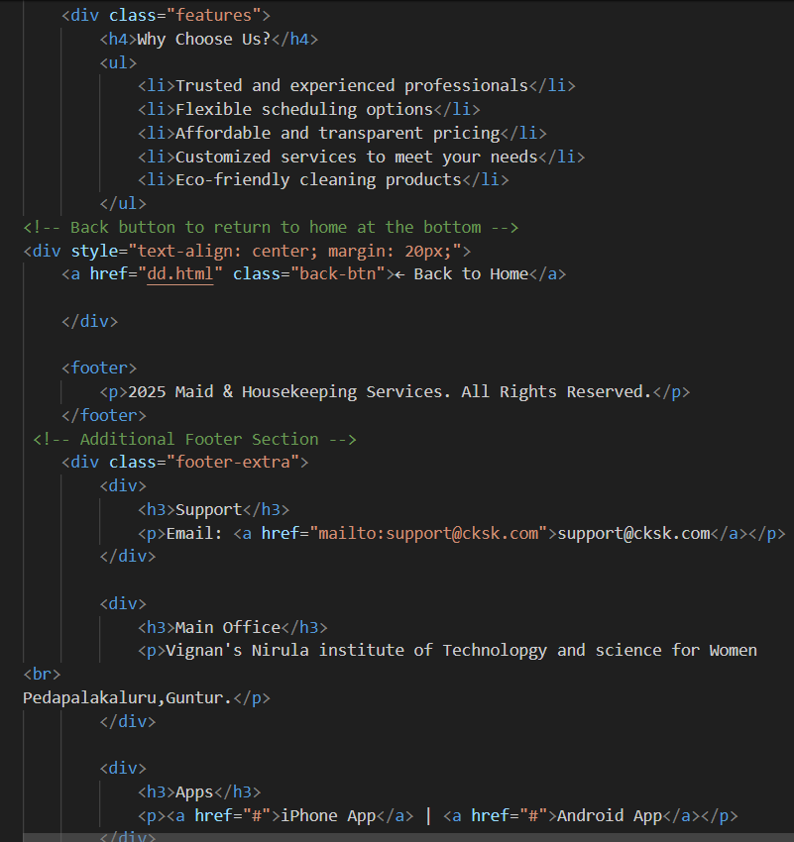

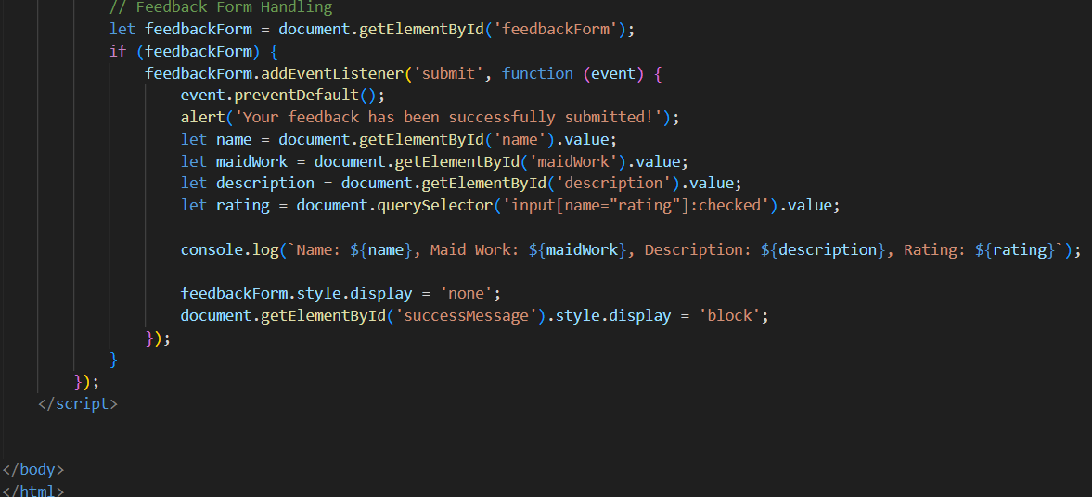

**cart.html**

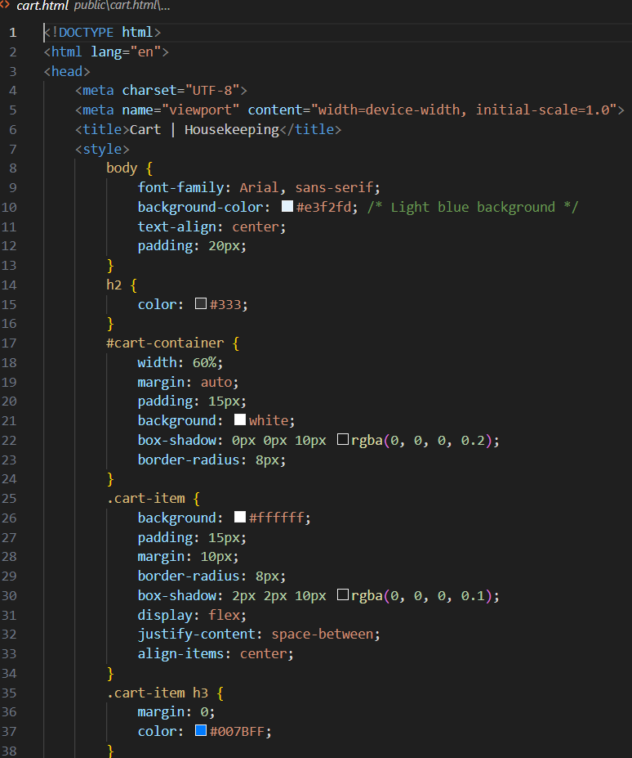

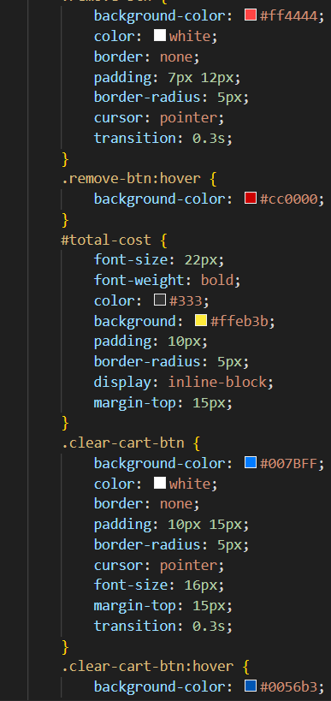

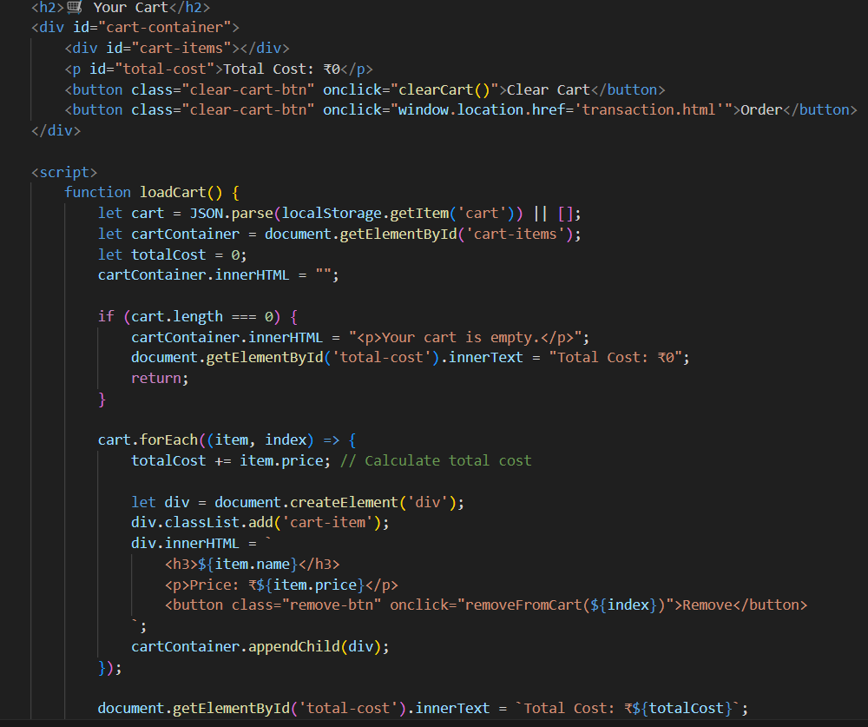

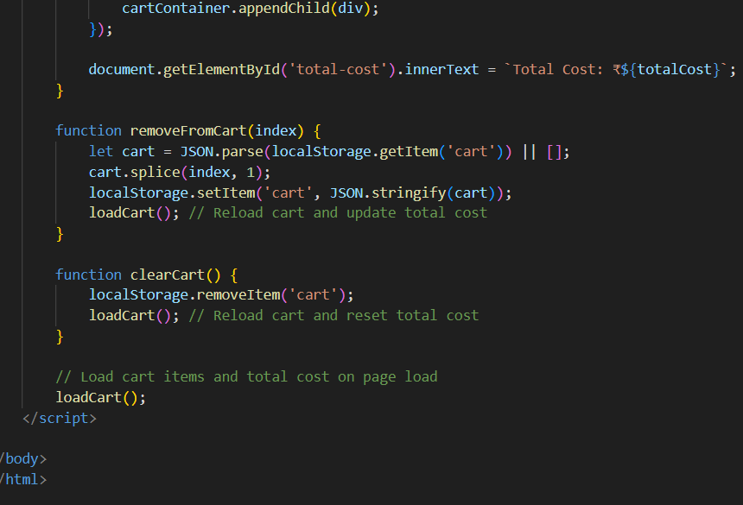

**Transaction.html**

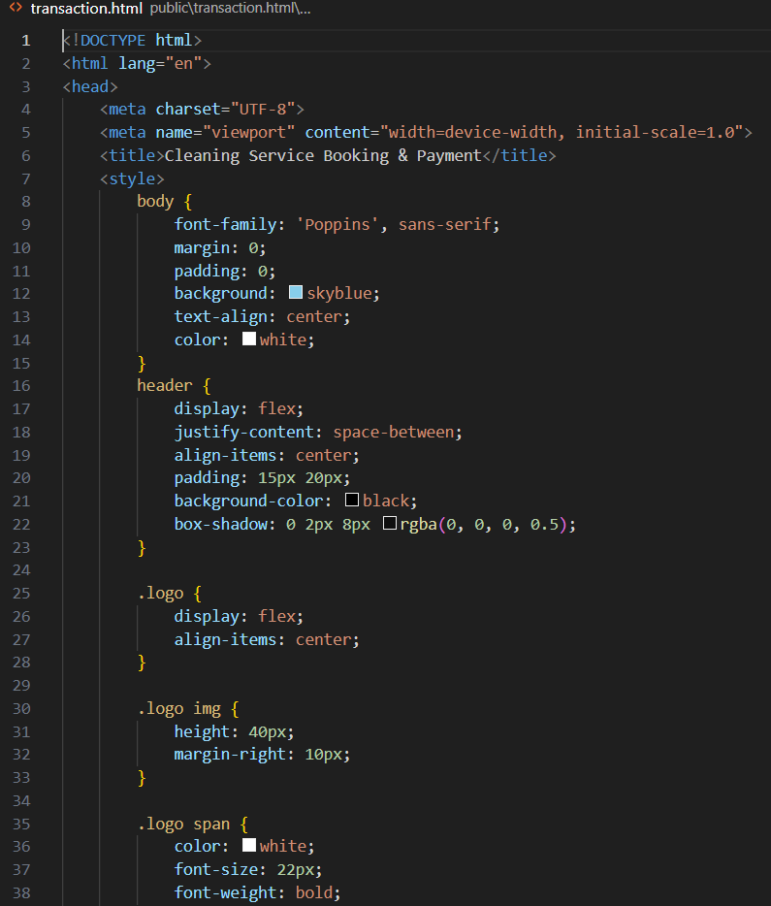

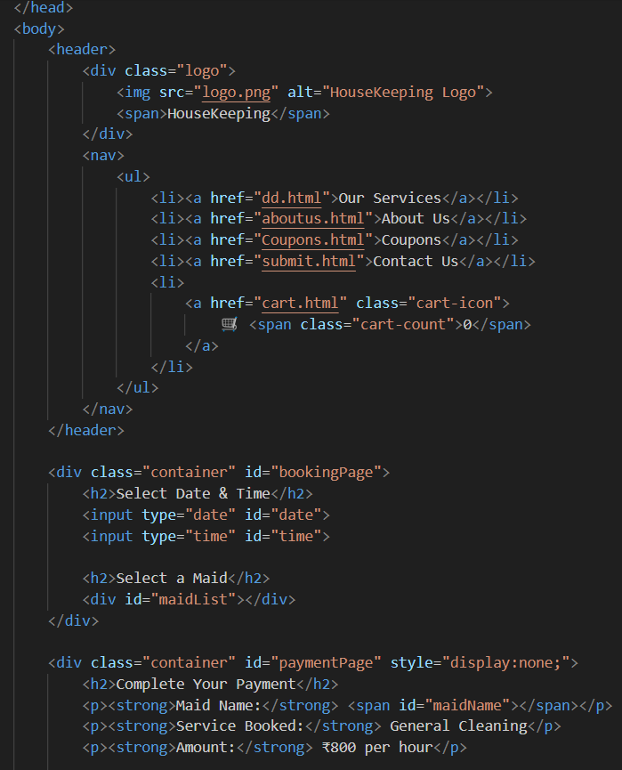

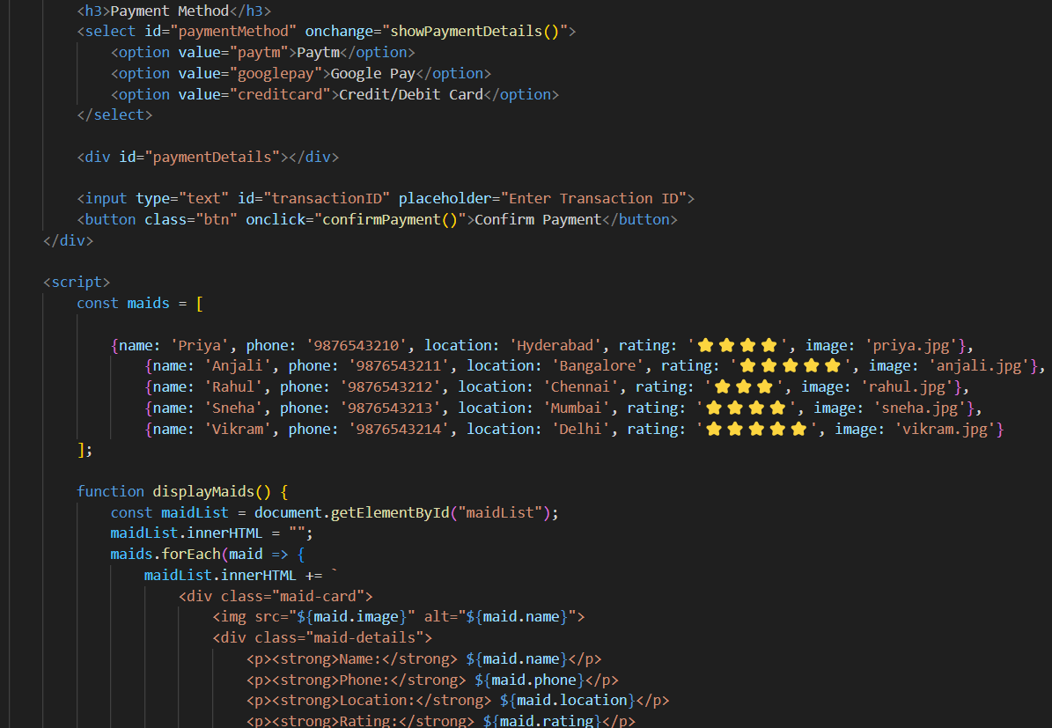

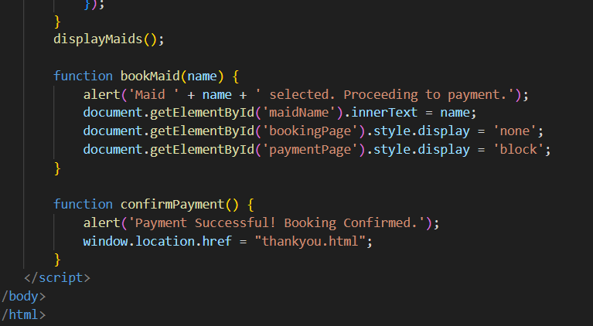

**maid1.html(for maid booking)**

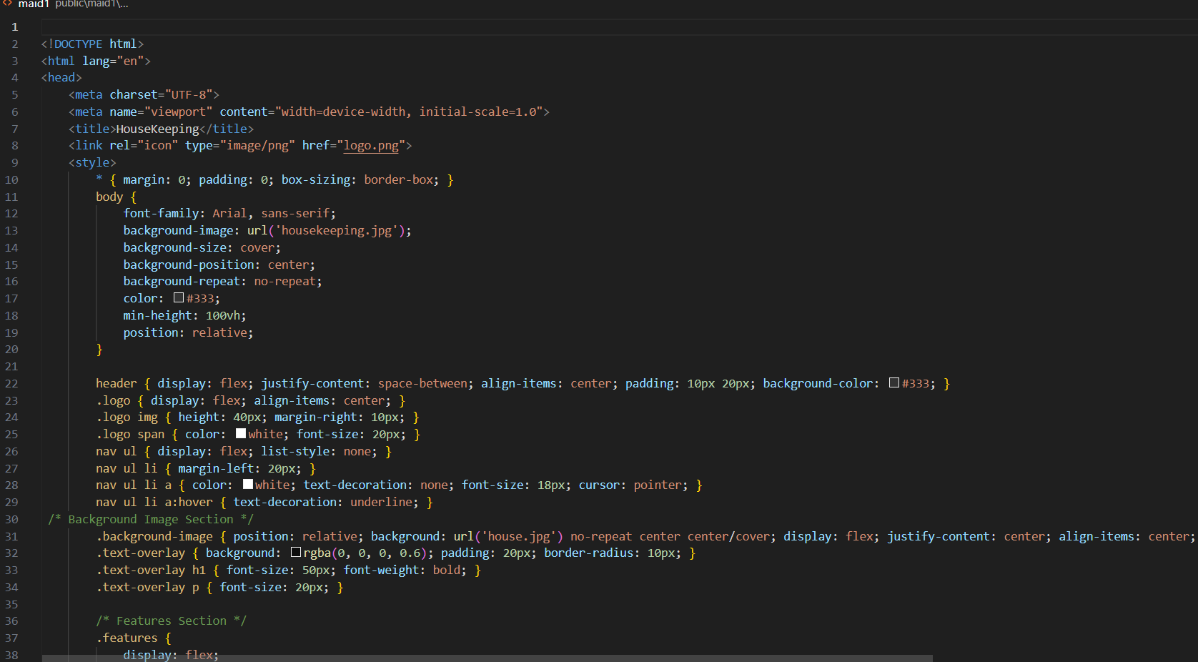

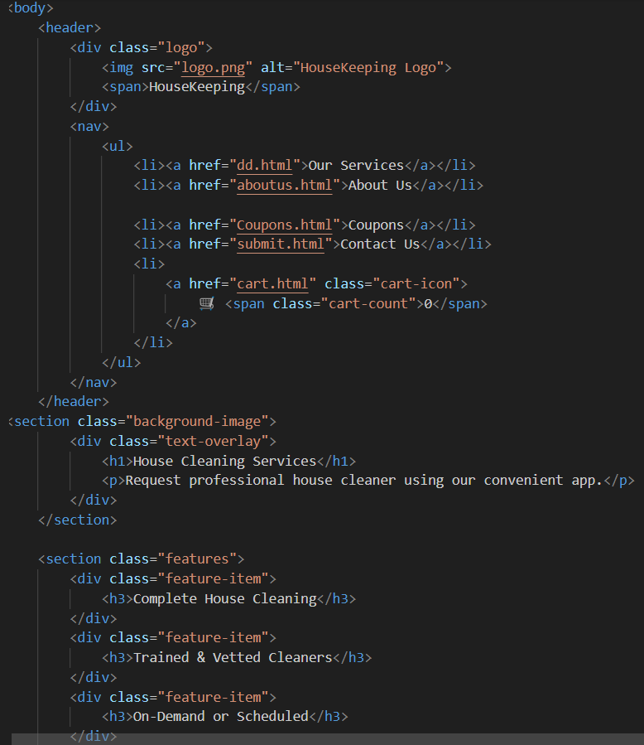

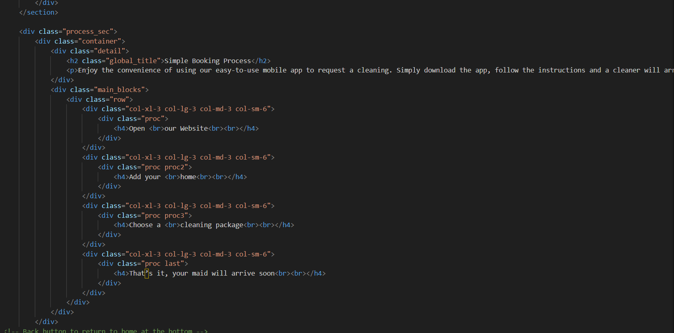

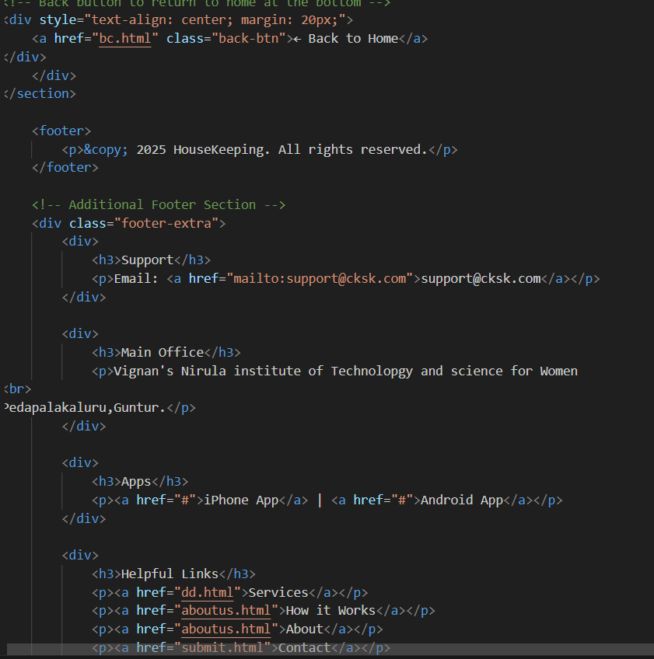

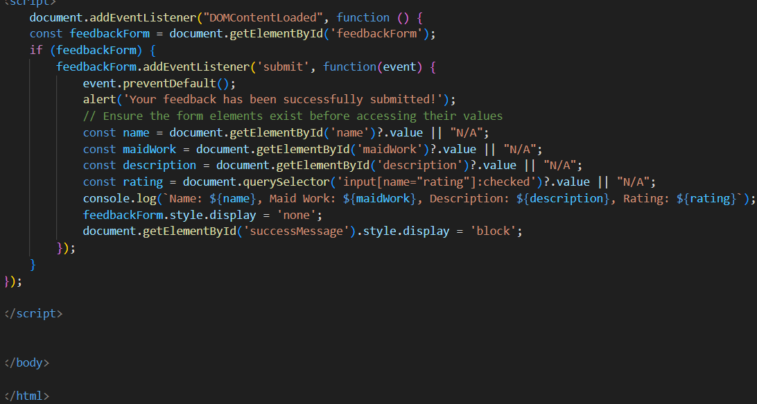

**cupons.html**

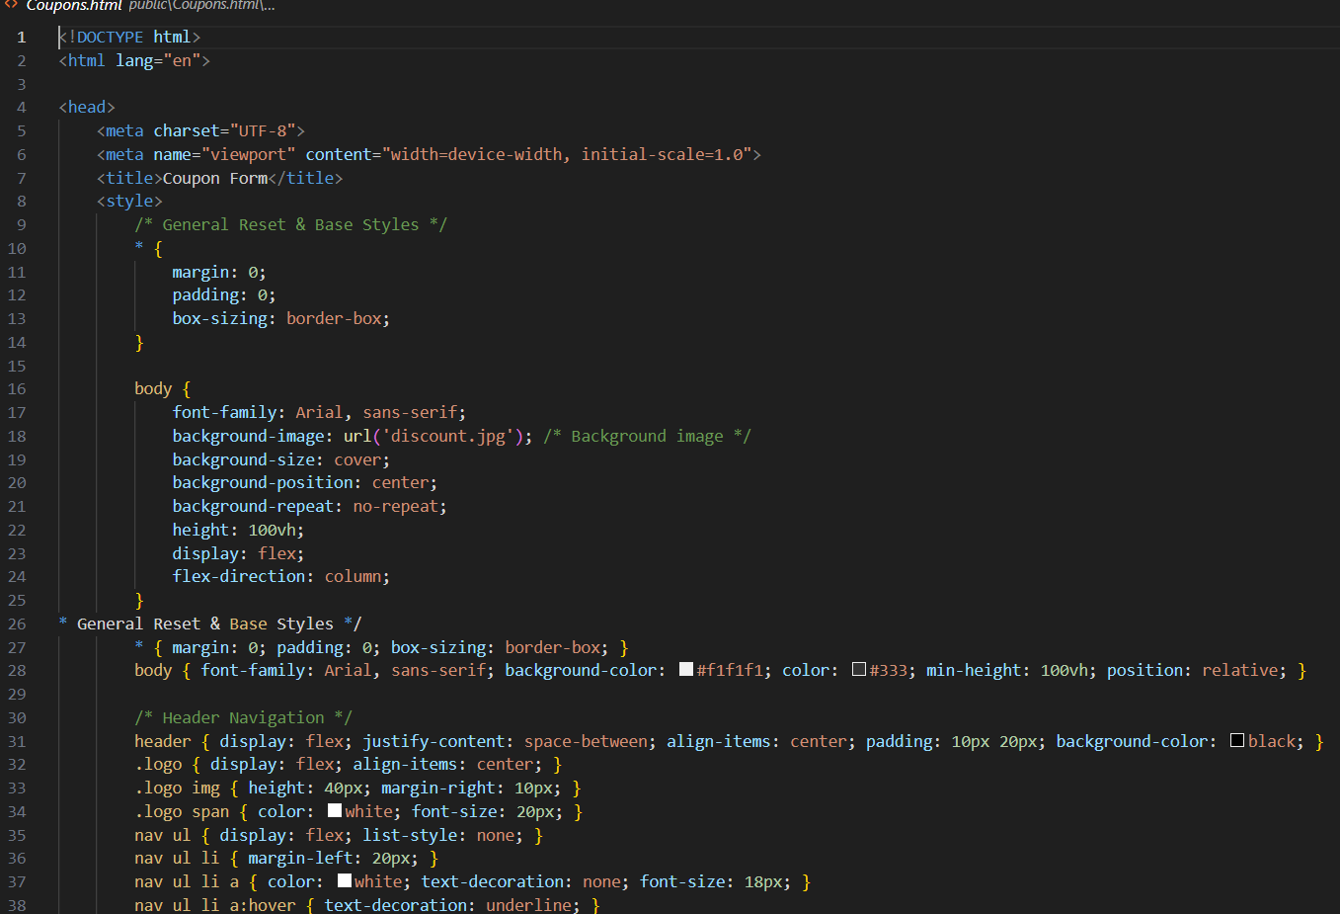

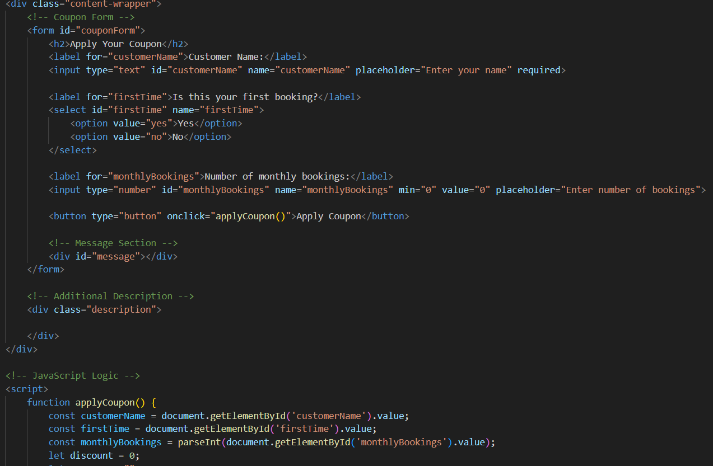



**submit.html(contact us)**

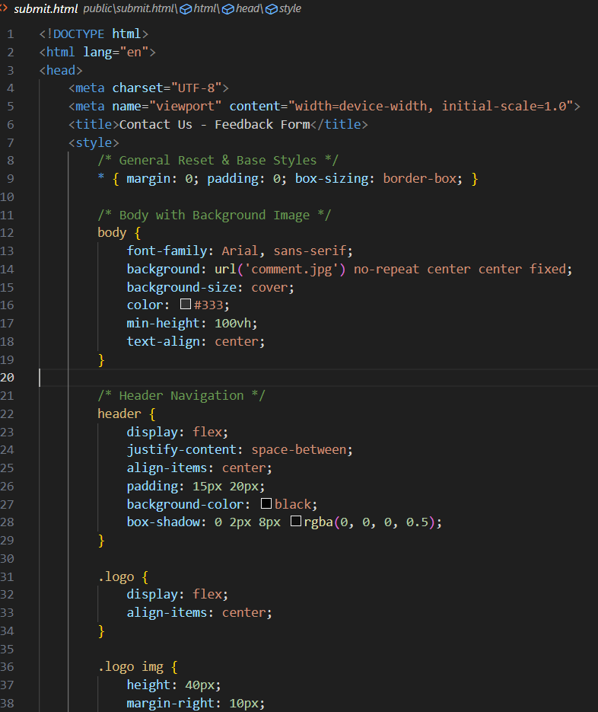

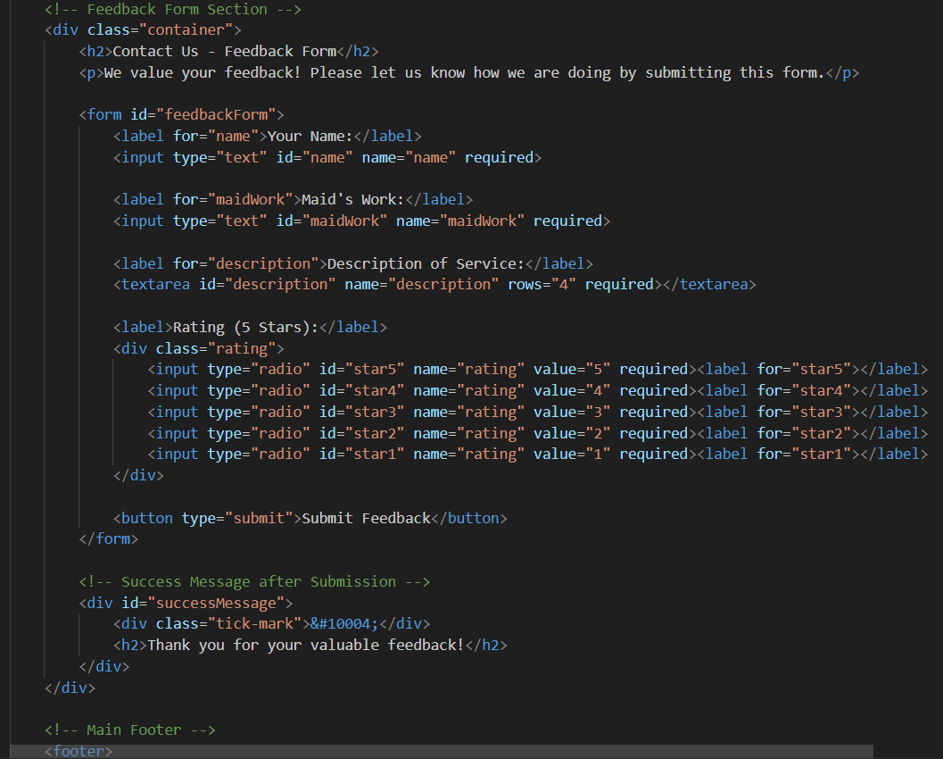

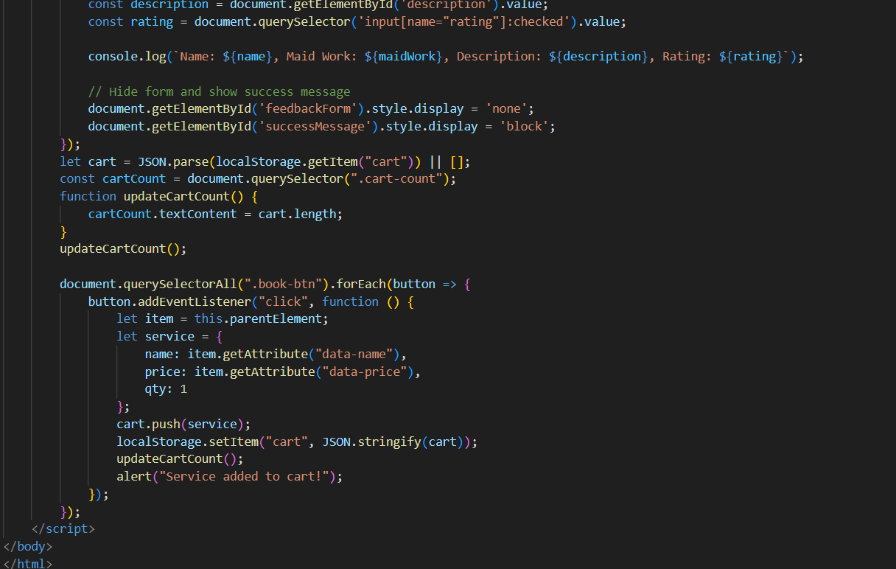

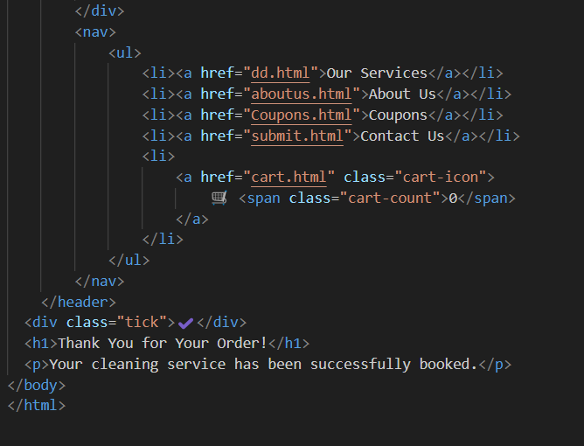

**Thankyou.html**

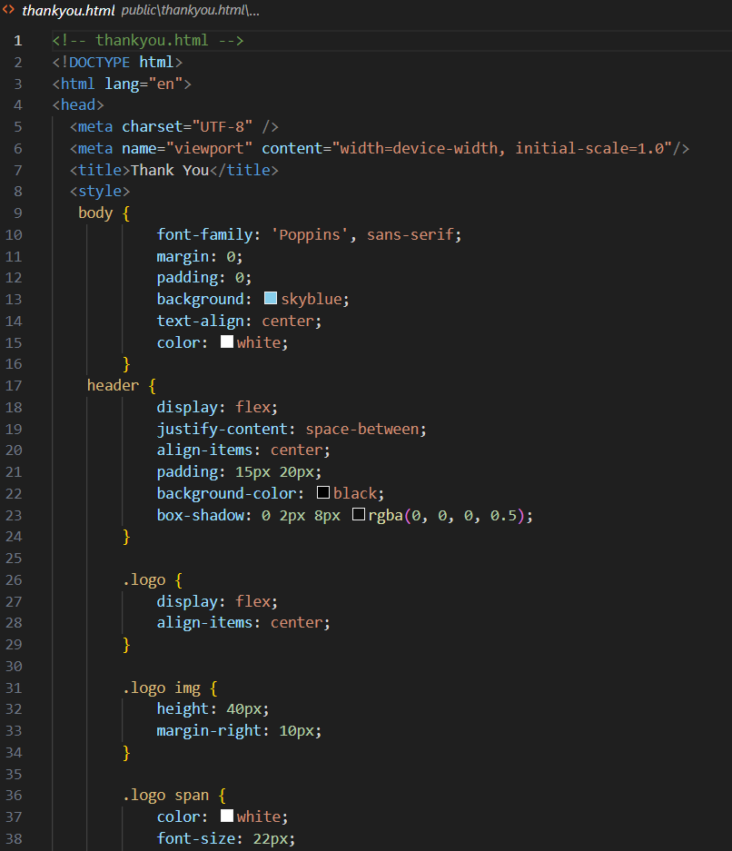



**Services.html (General cleaning, bathroom cleaning, laundry, kitchen cooking &cleaning, pet care , babysitting)**

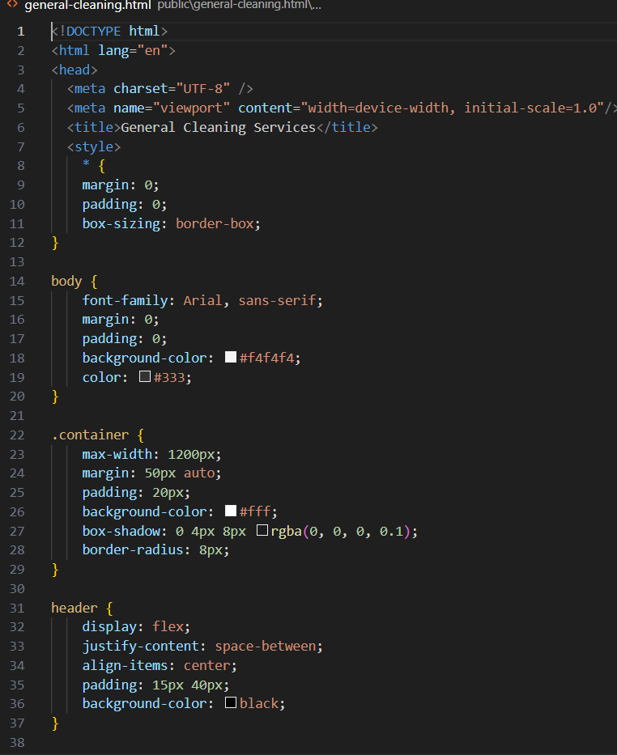

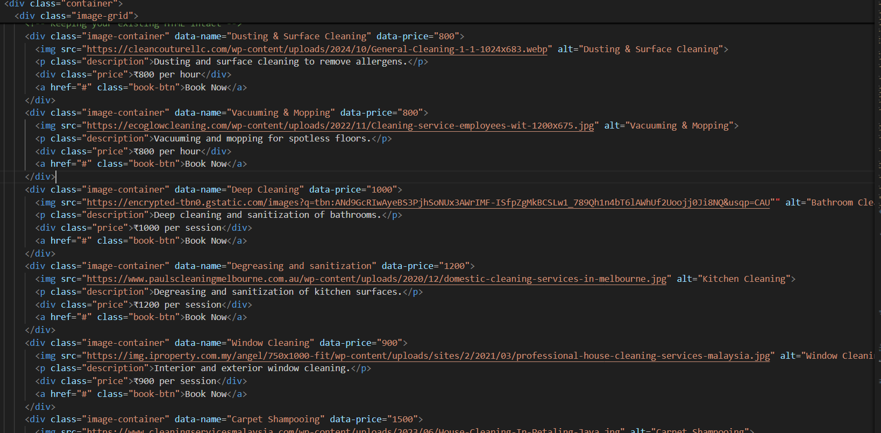

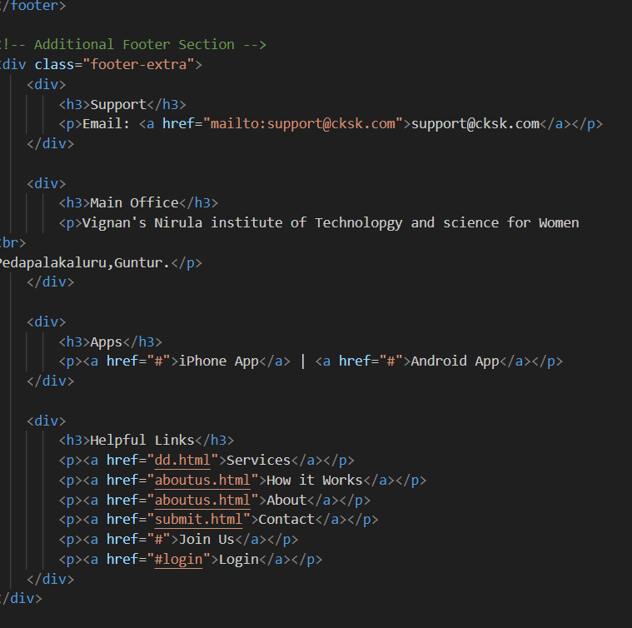

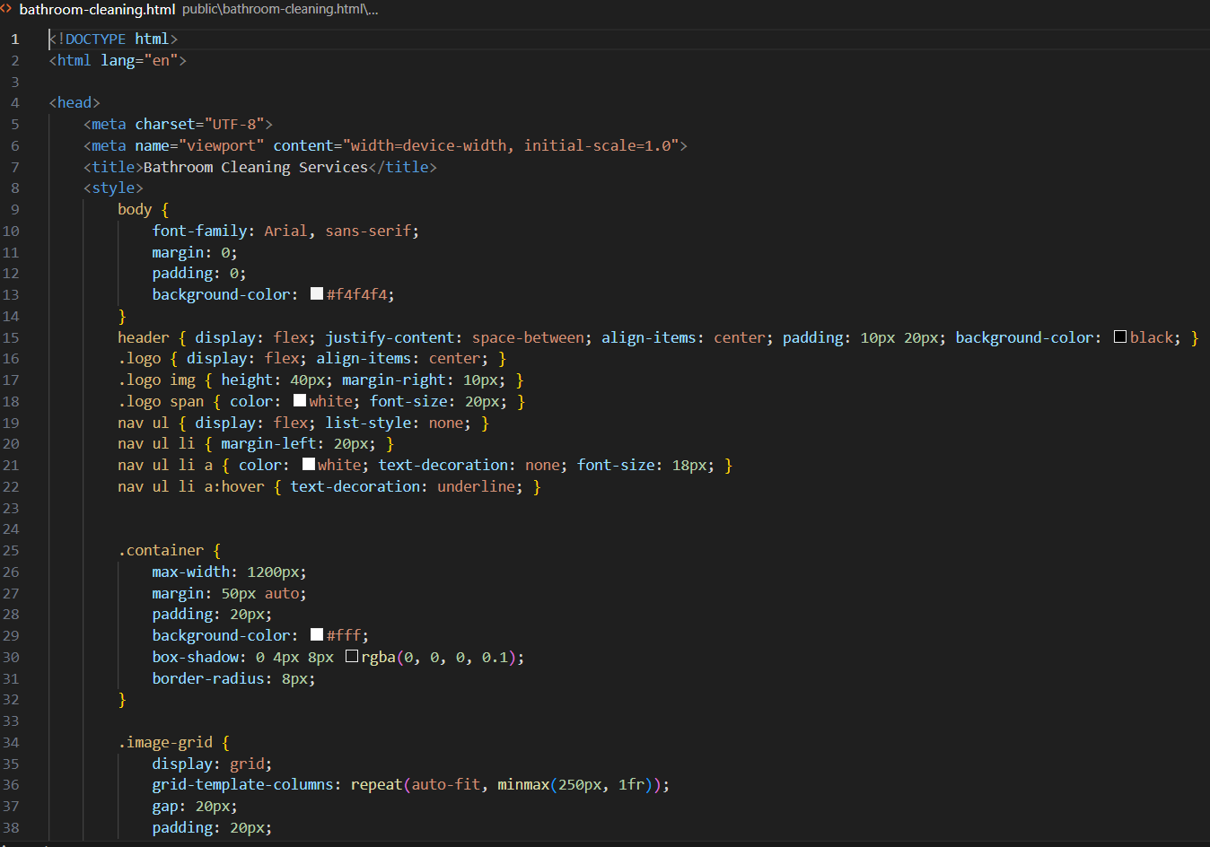

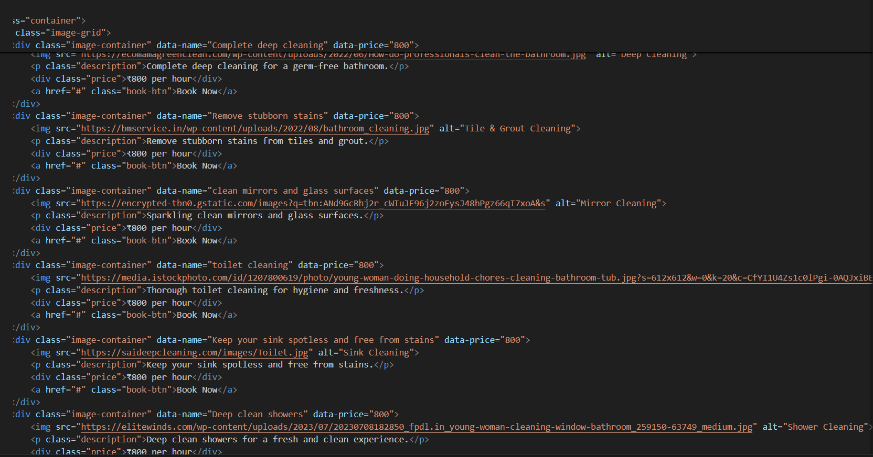

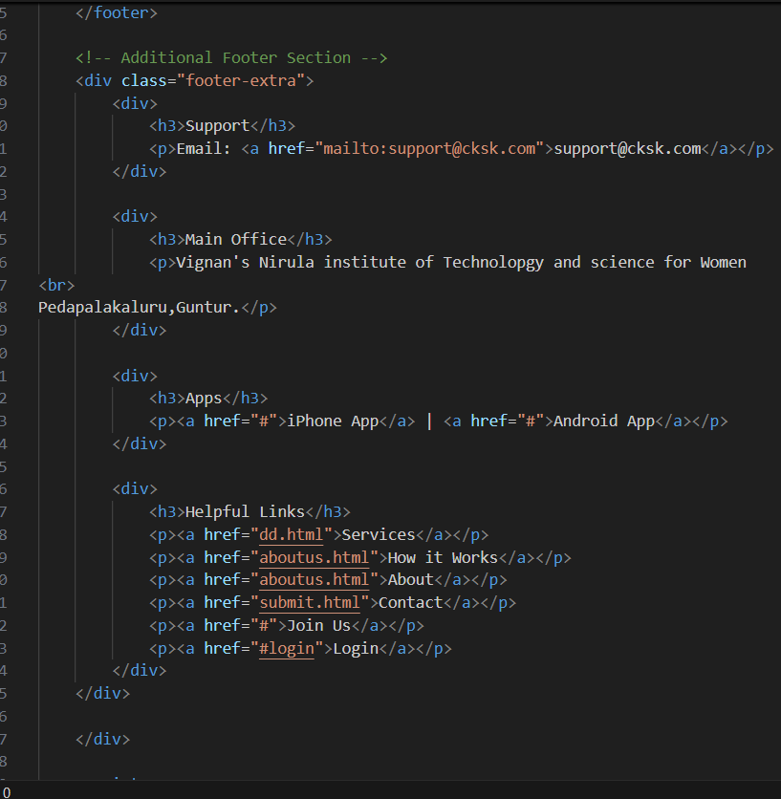

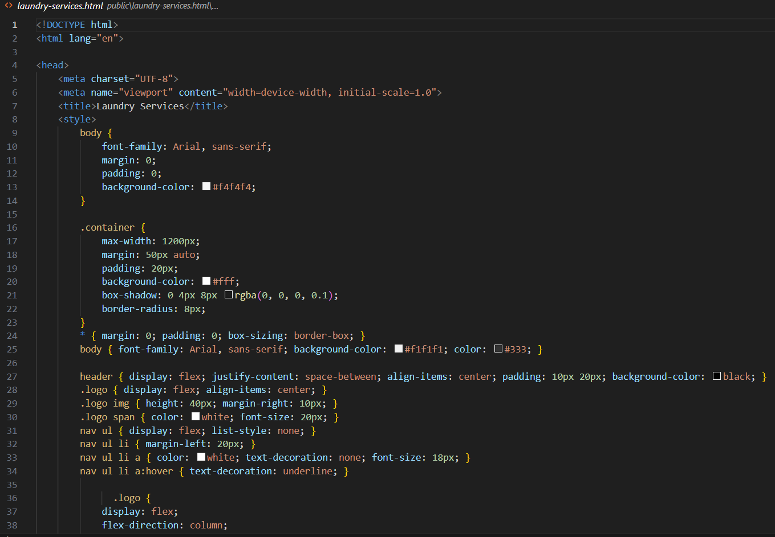

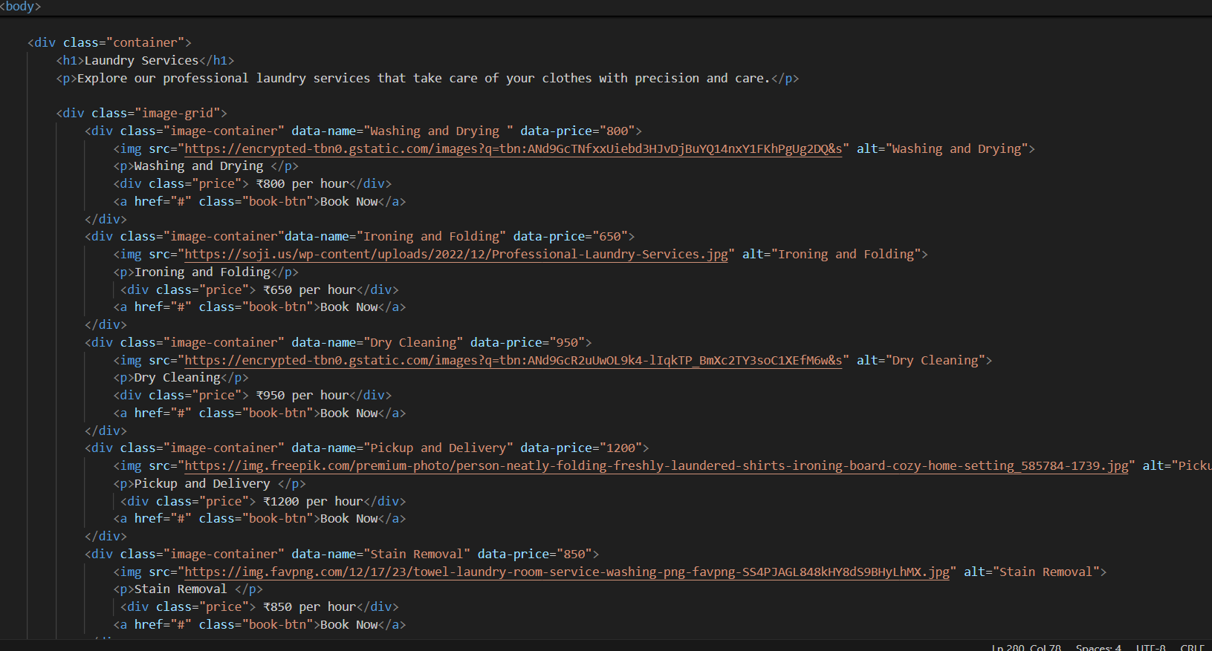

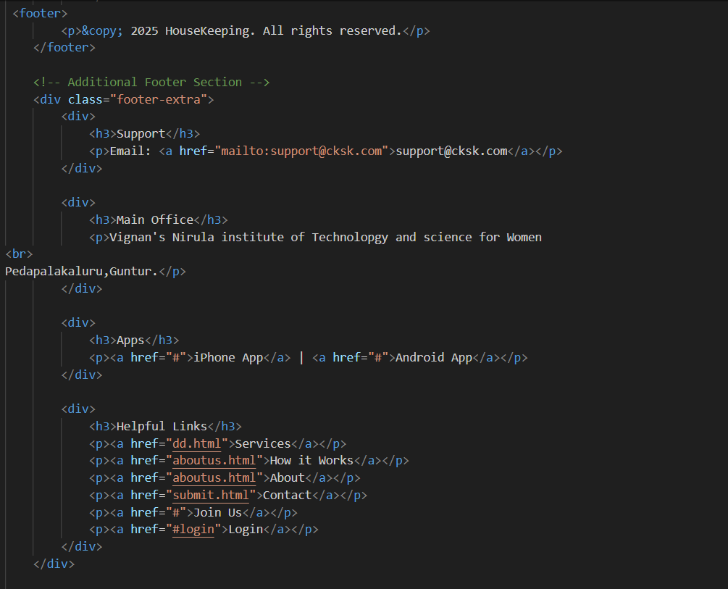

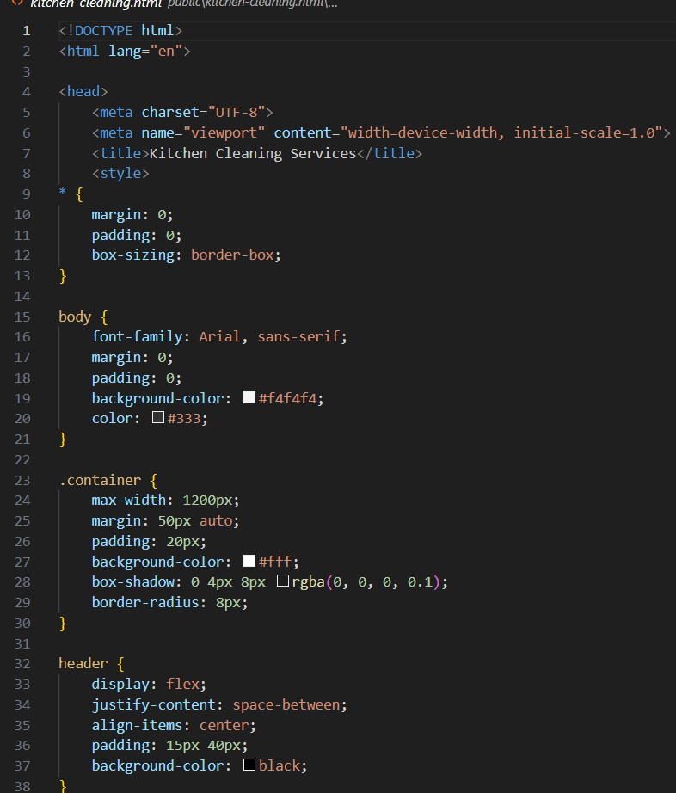

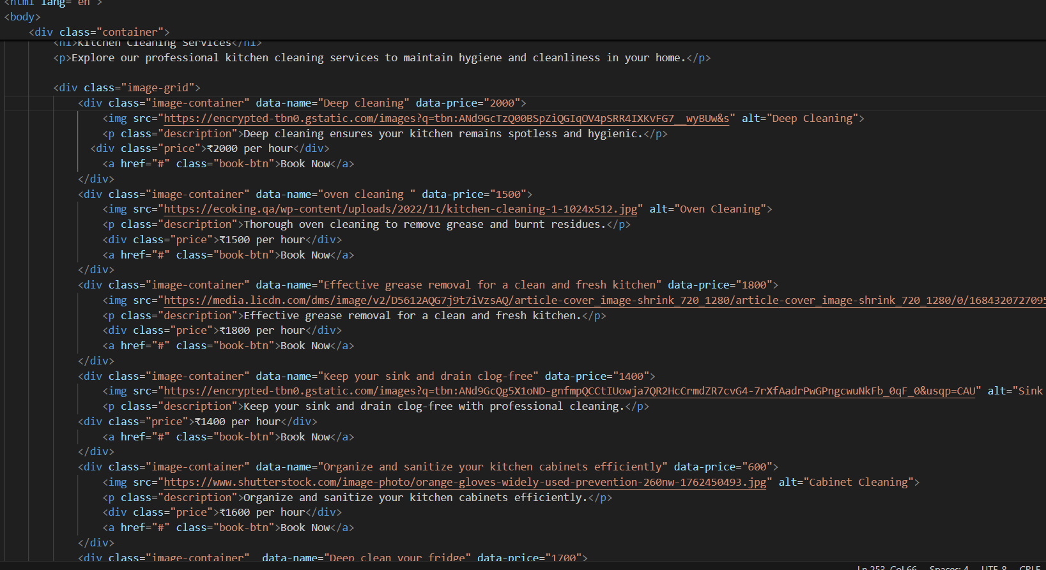

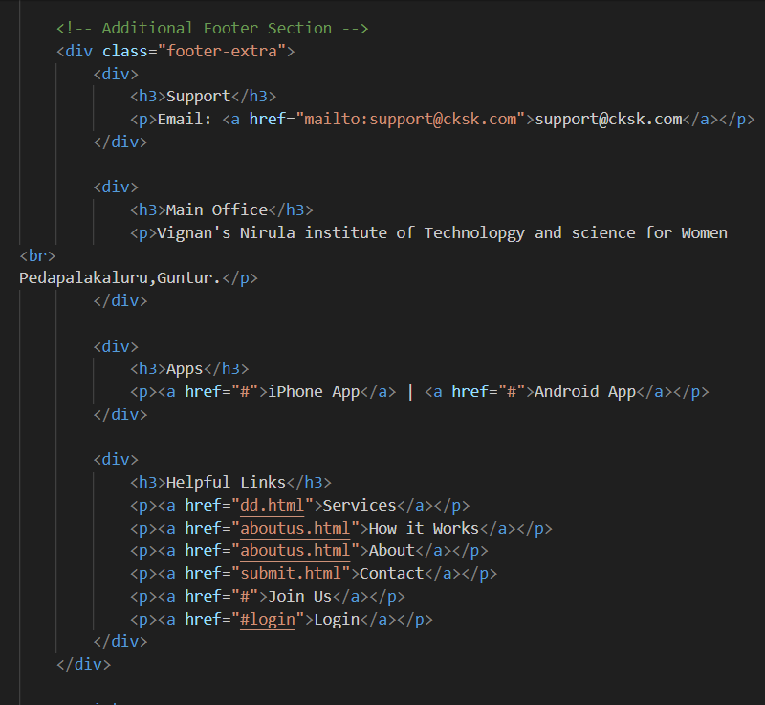

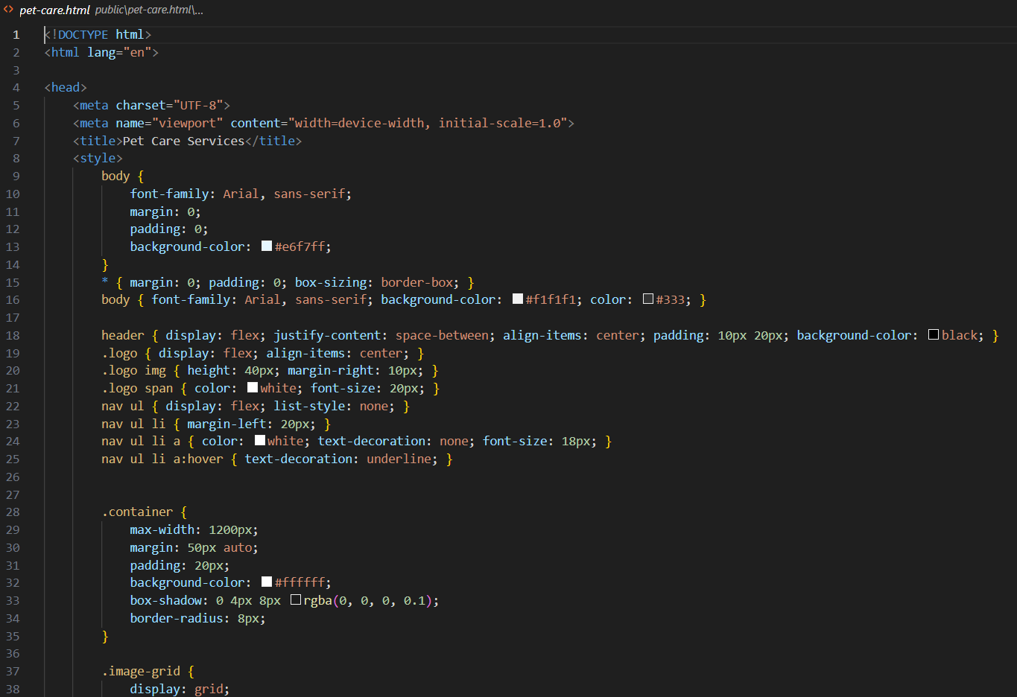

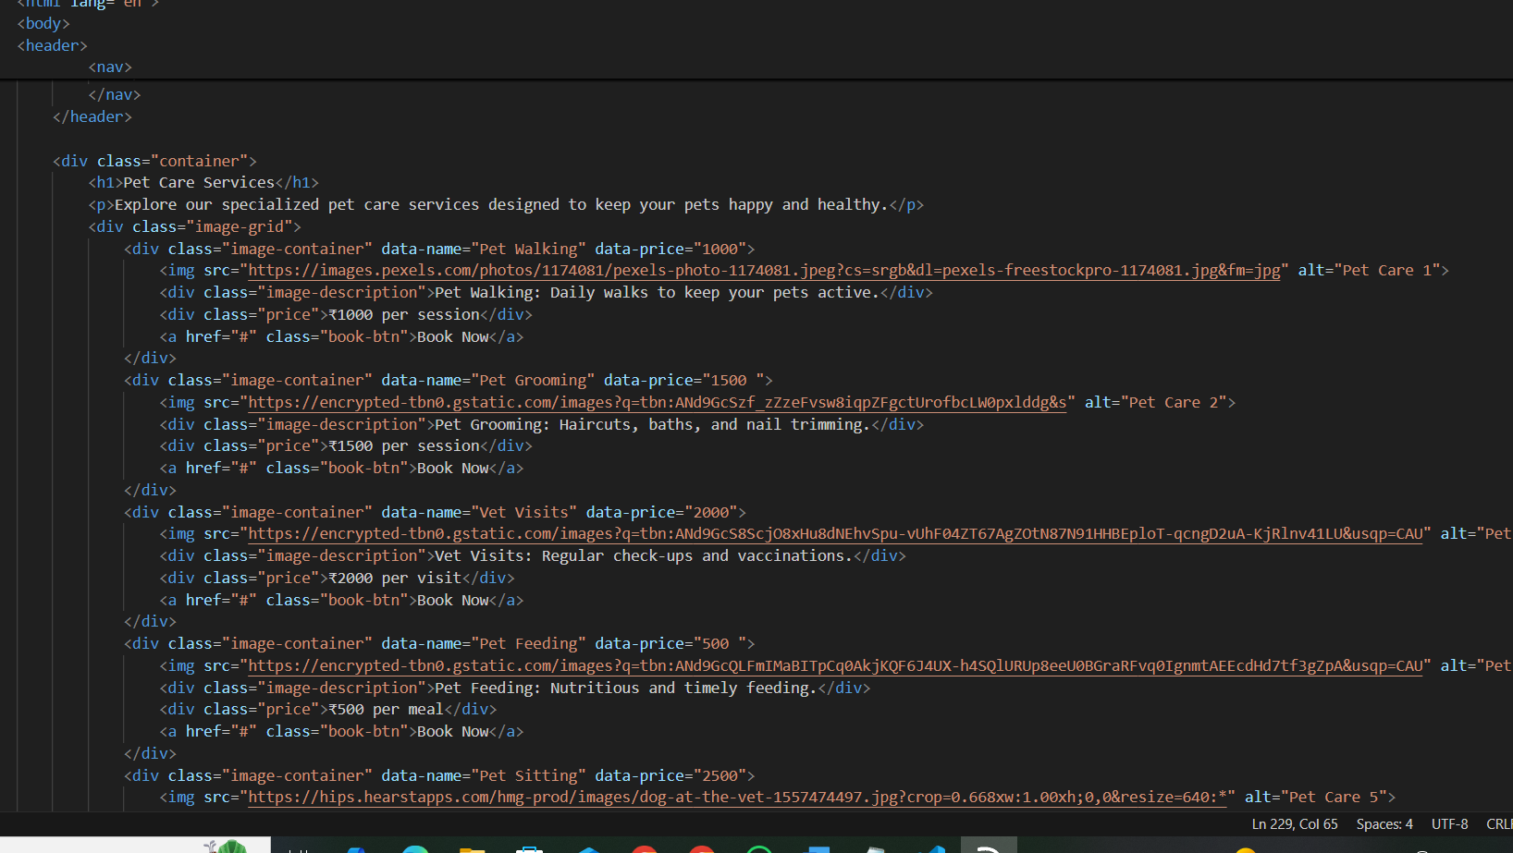

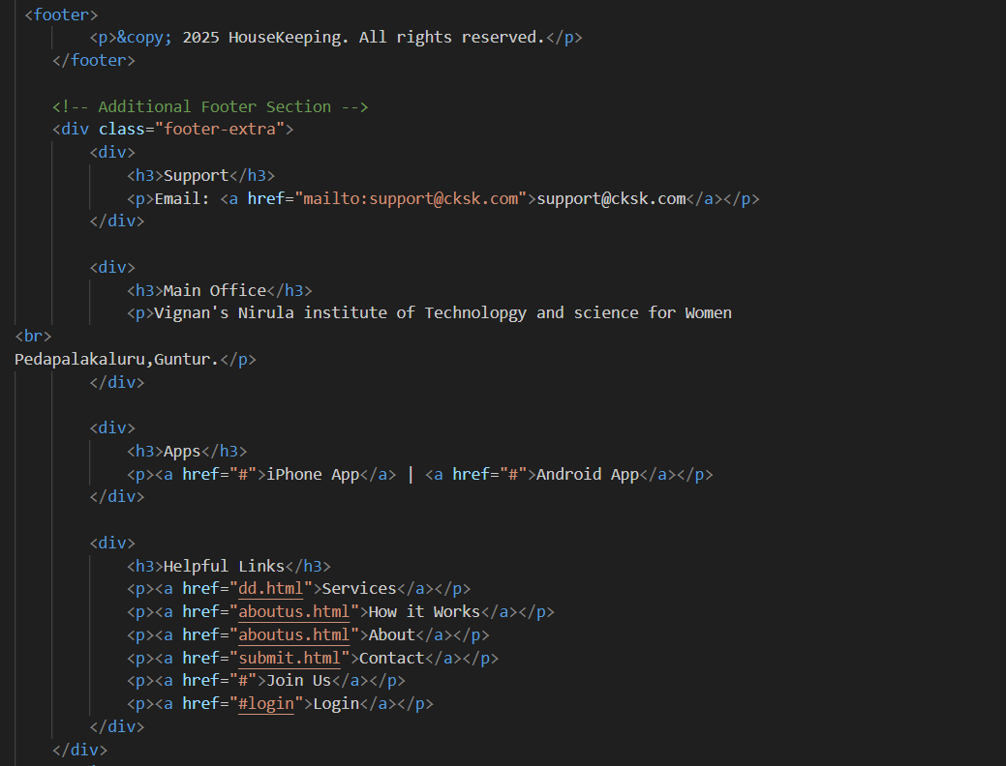

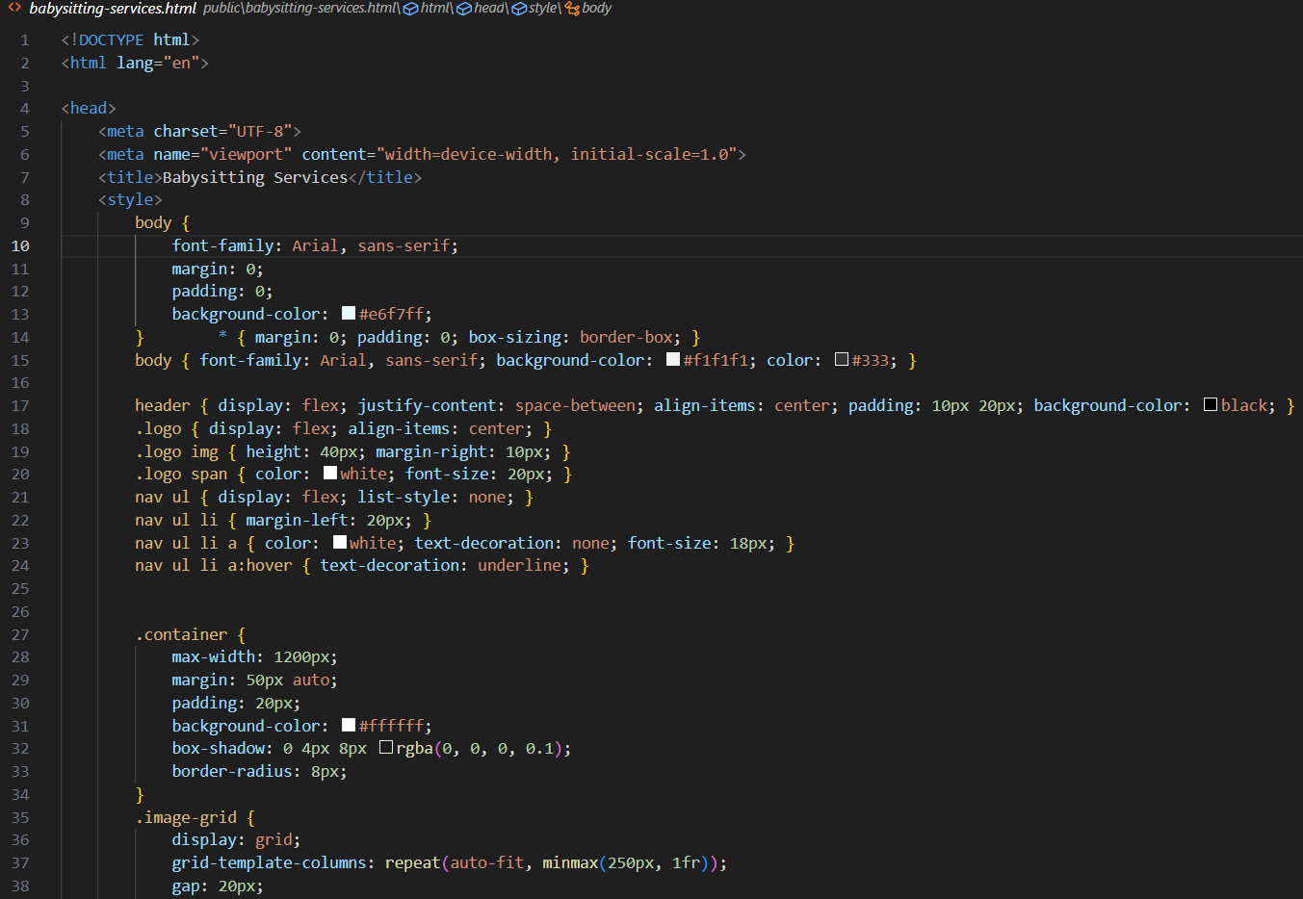

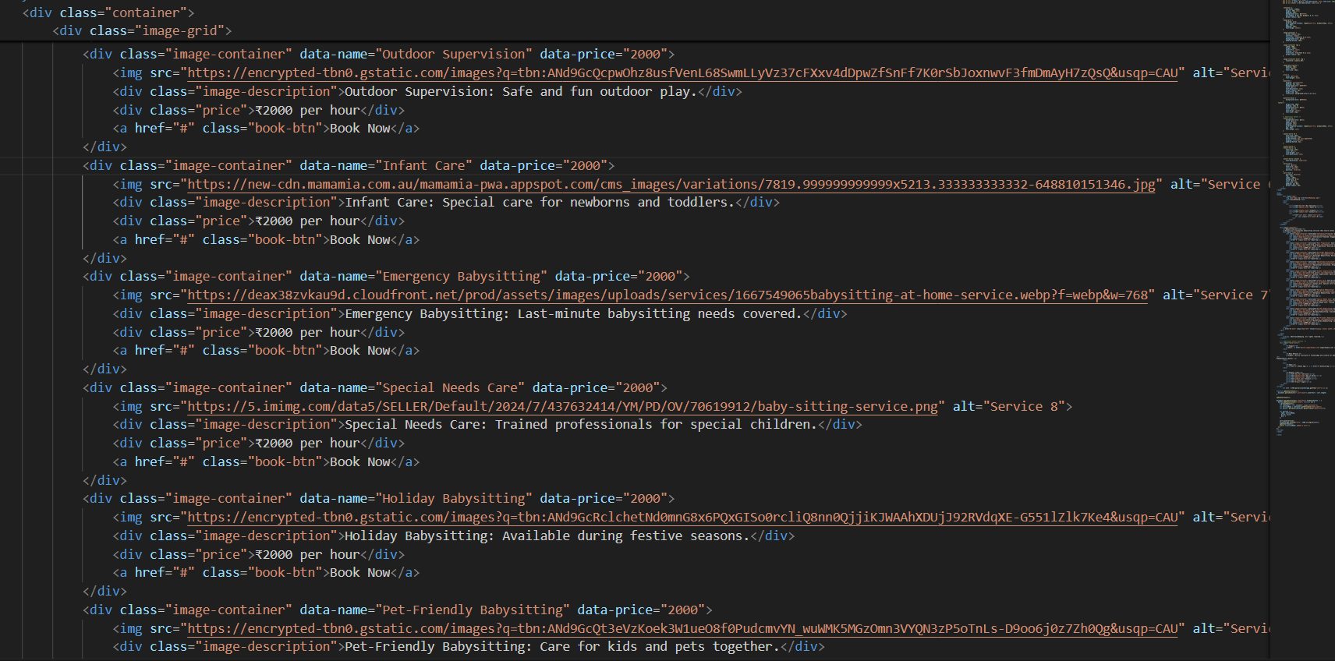

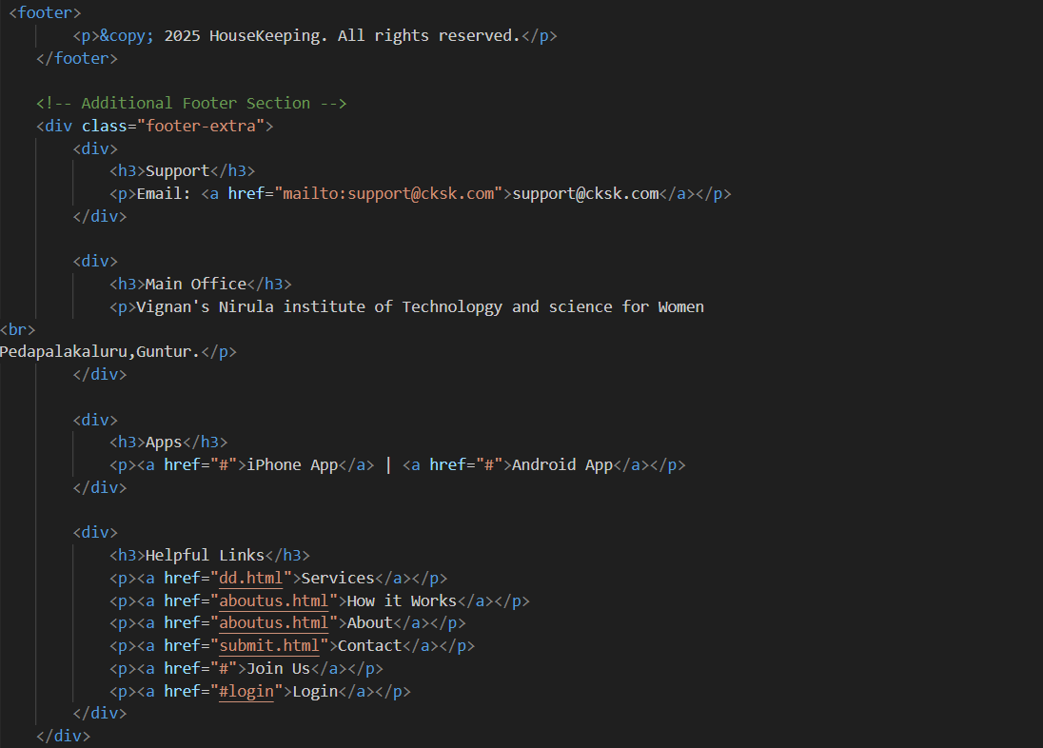

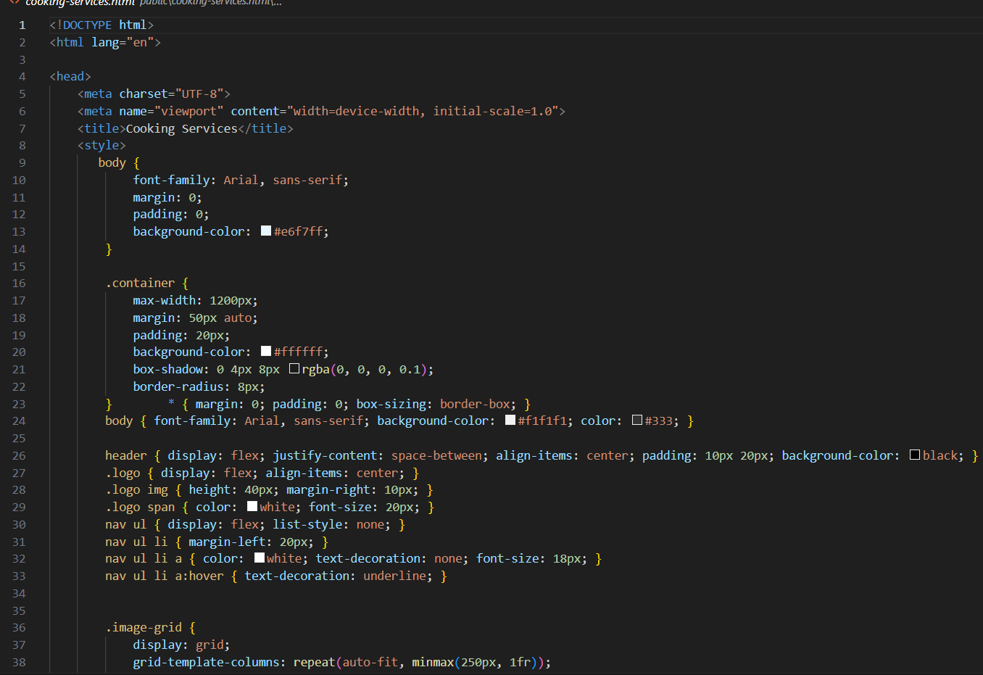

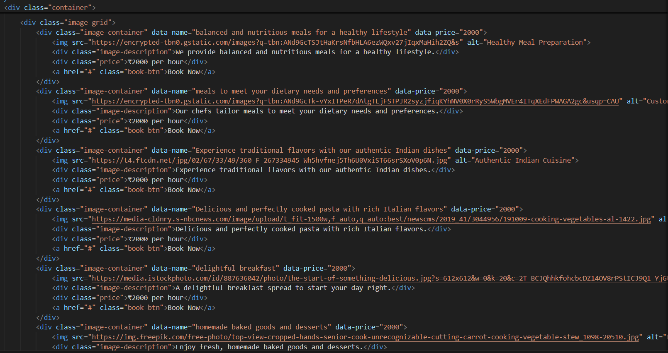

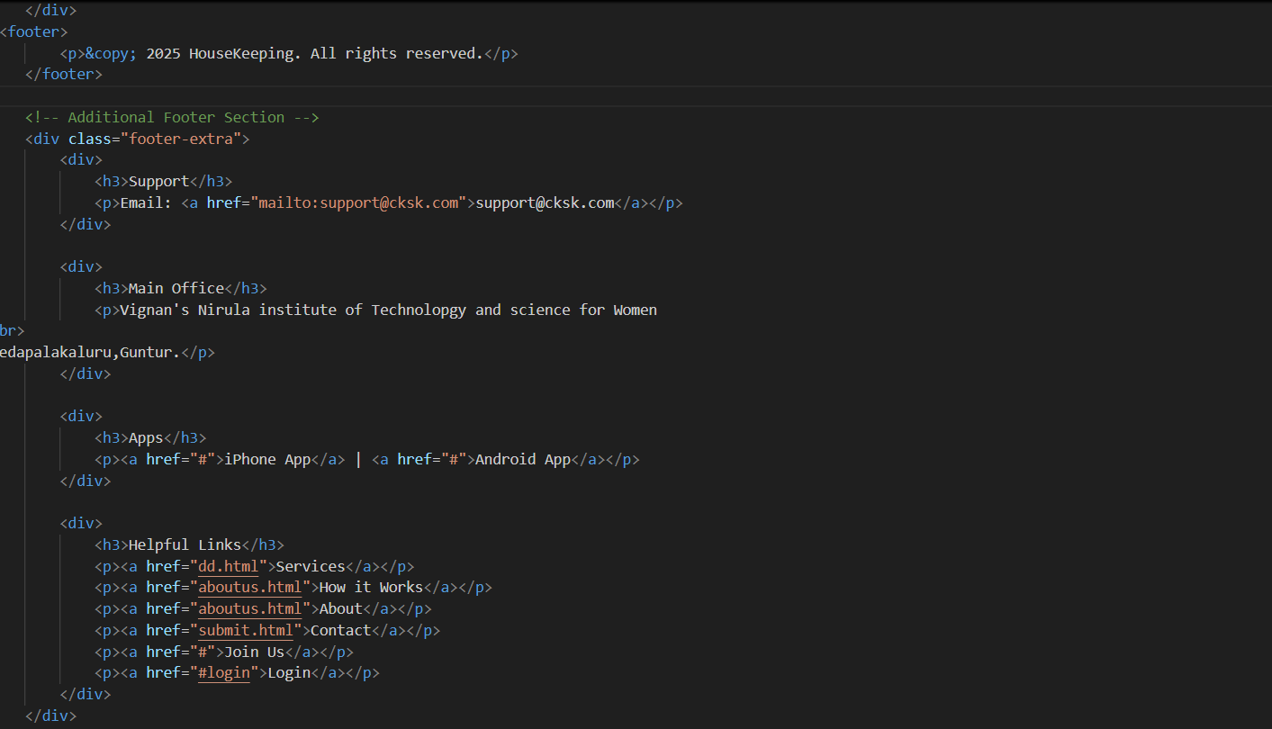

**Backend:**

**.env**

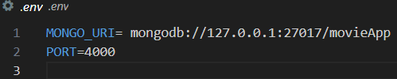

**app.js**

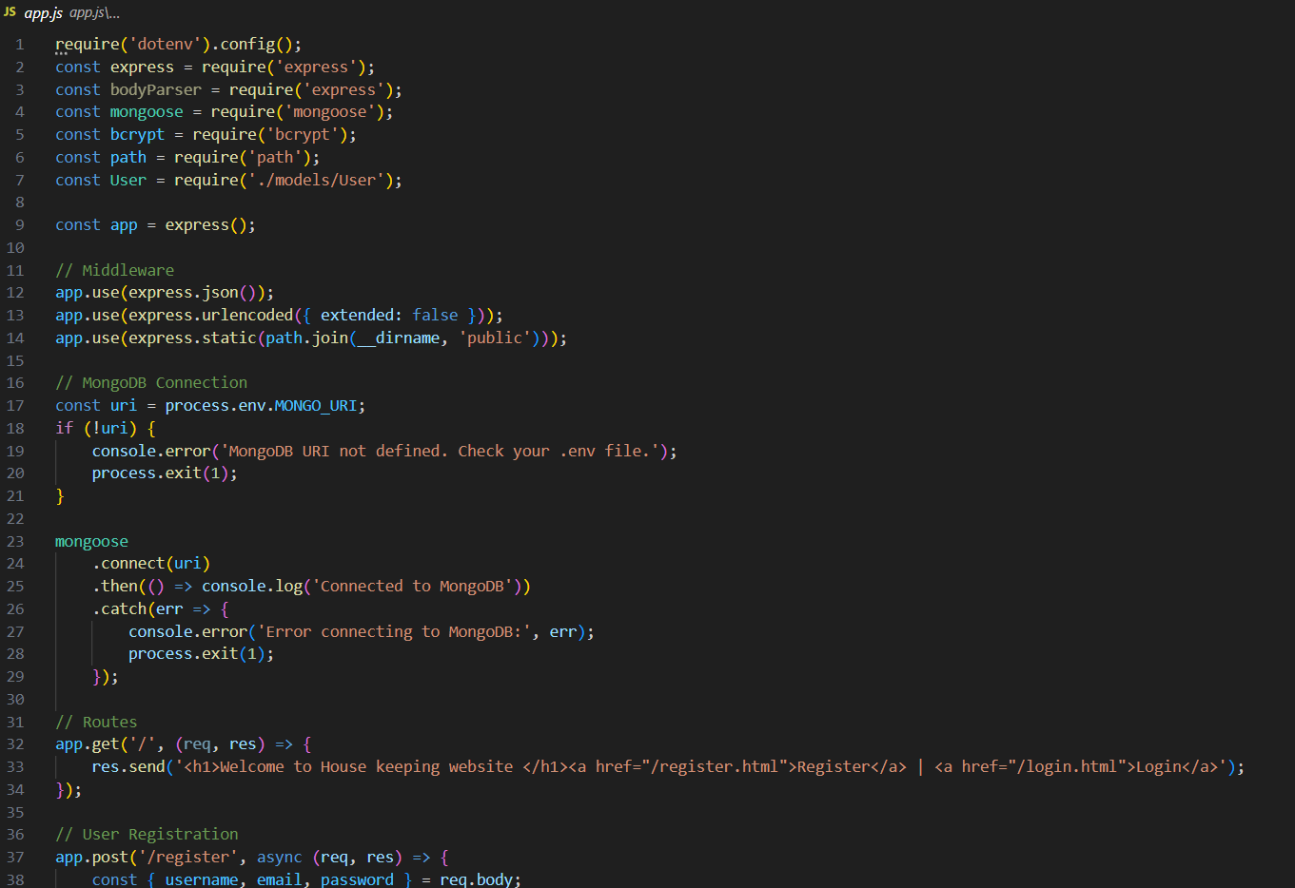

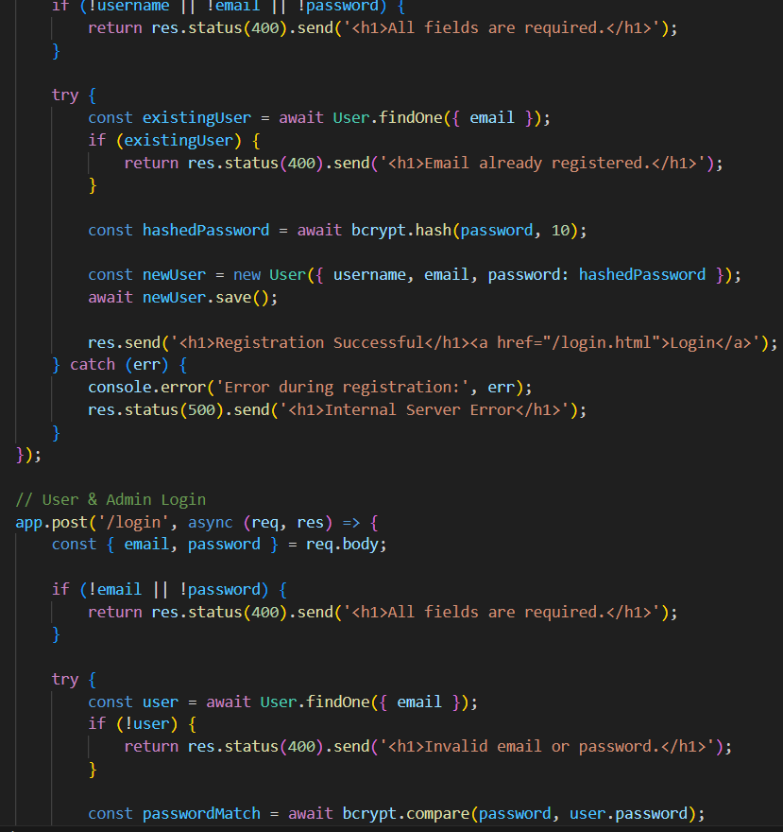

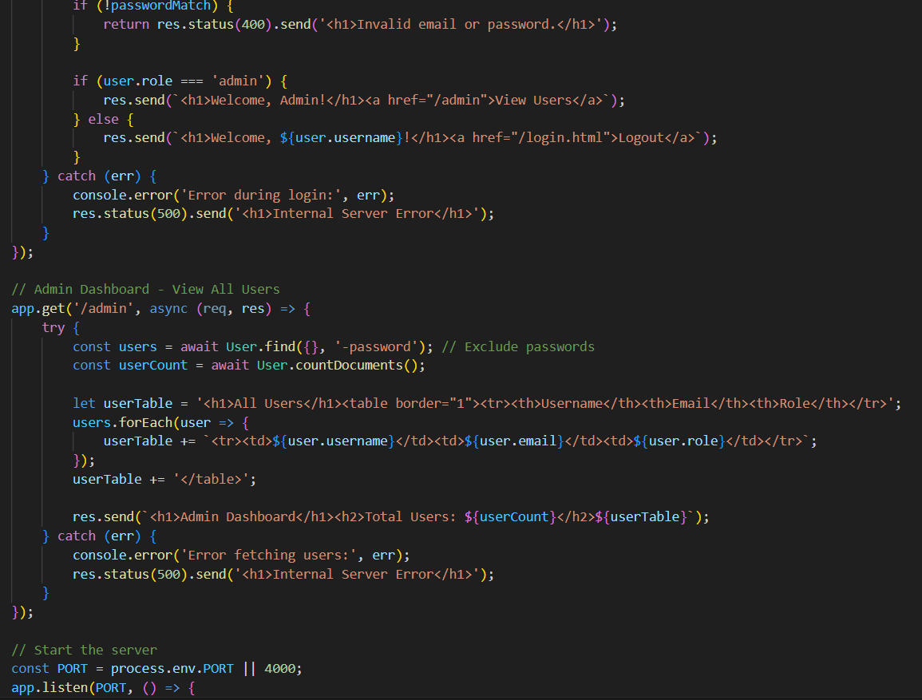

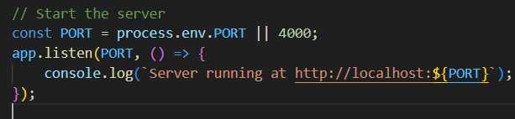

**createAdimn.js**

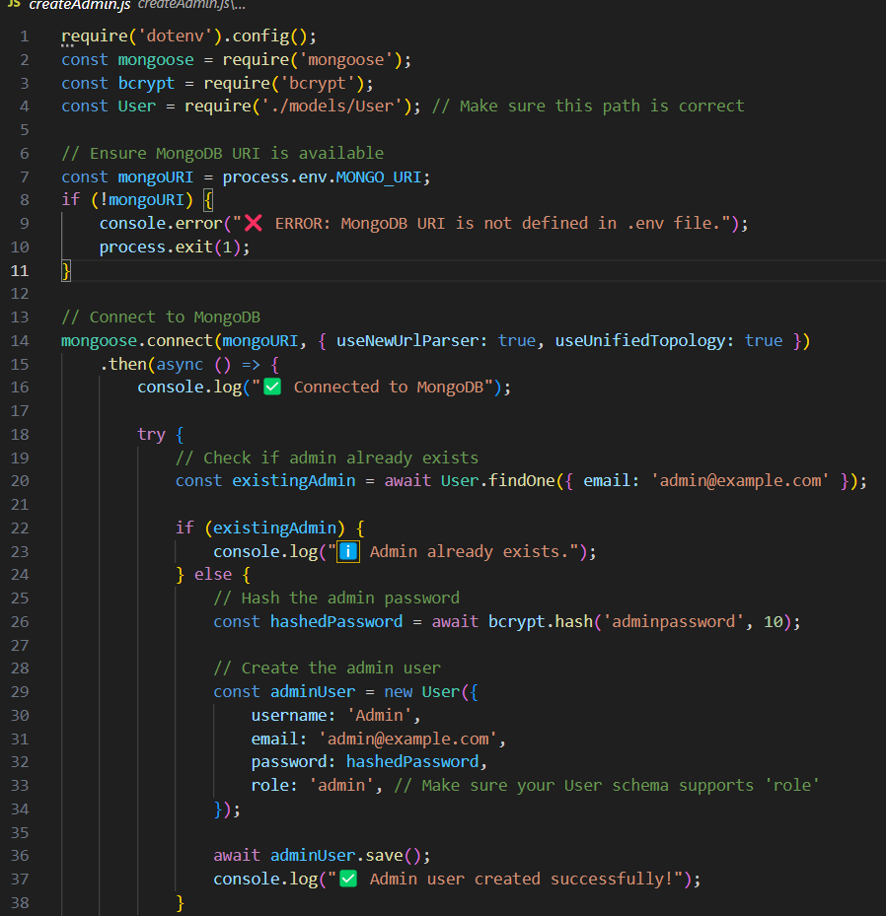

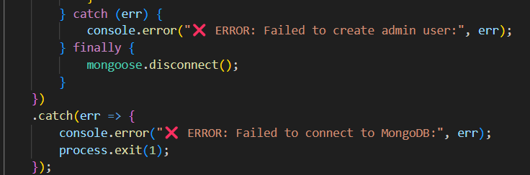

**Screen shots:**

